Software Requirements Specification

for

GameGuessr
Version 3.1 approved
Prepared by Group 4
Binus University
25 February 2026
Table of Contents
Table of Contents ii
Revision History ii
1. Introduction 1
1.1 Purpose 1
1.2 Document Conventions 1
1.3 Intended Audience and Reading Suggestions 2
1.4 Product Scope 3
1.5 References 3
2. Overall Description 4
2.1 Product Perspective 4
2.2 Product Functions 5
2.3 User Classes and Characteristics 6
2.4 Operating Environment 7
2.5 Design and Implementation Constraints 8
2.6 User Documentation 9
2.7 Assumptions and Dependencies 9
2.8 Development Schedule (SDLC) 10
3. External Interface Requirements 15
3.1 User Interfaces 15
3.2 Hardware Interfaces 33
3.3 Software Interfaces 33
3.4 Communications Interfaces 35
4. System Features 36
4.1 Authentication and Authorization 36
4.2 Uploader Module - Content Upload and Quiz Configuration 37
4.3 Quiz Module - Real‑Time Quiz Session Management 38
4.4 Leaderboard Module – Scoring and Ranking 39
4.5 Administrative Control Panel 40
5. Other Nonfunctional Requirements 41
5.1 Performance Requirements 41
5.2 Safety Requirements 41
5.3 Security Requirements 41
5.4 Software Quality Attributes 42
5.5 Business Rules 42
6. Other Requirements 43
6.1 Pre-Seeded Quiz Content 43
6.2 Audio Assets 43
6.3 Quiz Upload File Format (.txt) 43
Appendix A: Glossary 44
Appendix B: Analysis Models 45
Appendix C: To Be Determined List 83

Revision History
Name | Date | Reason For Changes | Version
Group 4 (Fairy, Jennifer, Jiovanny) | 28 February 2026 | Writing the introduction | 1.1
Group 3 (Albert, Gregorio, Jovan) | 31 March 2026 | Drafting sections 2.1 and 2.2 to establish the Overall Description. | 1.2
Group 3 (Albert, Gregorio, Jovan) | 1 April 2026 | Rewriting Chapter 2 to provide comprehensive content. | 1.3
Group 3 (Albert, Gregorio, Jovan) | 8 April 2026 | Deleting inaccurate information in section 2.1 to ensure correctness. | 1.4
Group 3 (Albert, Gregorio, Jovan) | 17 April 2026 | Replacing Chapter 2 with a new version to add missing details. | 1.5
Group 3 (Albert, Gregorio, Jovan) | 22 April 2026 | Writing Chapters 3 to 5 and adding UML diagrams to finalize system | 1.6
Group 3 (Albert, Gregorio, Jovan) | 23 April 2026 | Polishing the document layout and formatting for consistency. | 1.7
Group 3 (Albert, Gregorio, Jovan) | 29 April 2026 | Update figma landing page and leaderboard page in github | 2.0
Group 3 (Albert, Gregorio, Jovan) | 20 May 2026 | Push Backend and Frontend in github | 2.1
Group 3 (Albert, Gregorio, Jovan) | 2 Juni 2026 | Update Backend and Frontend in github | 2.2
Group 3 (Albert, Gregorio, Jovan) | 10 Juni 2026 | Revision Diagram | 3.0
Group 3 (Albert, Gregorio, Jovan) | 11 Juni 2026 | Revision Use Case Description | 3.1

Introduction

Purpose
The primary objective of this document is to provide a detailed explanation about GameGuessr. GameGuessr is a website-based quiz game. This document outlines the purpose, features, system interfaces, functionalities and limitations of GameGuessr. It is intended to serve as a crucial roadmap for developers and stakeholders, ensuring effective collaboration and communication throughout the development process. By providing a clear scope about the projects' objectives, this document aims to facilitate seamless development, testing, integration and deployment of the website. In addition, this document serves as a reference for future modifications and improvements, as the system will adapt continuously according to the user feedback. It will be submitted to Binus for its approval.
The release version of GameGuessr is 1.0.0-MVP. The development cycle consists of 4 phases and each phase will be conducted within 1 month. The SRS scope of this product includes 3 main subsystems which are the uploader module, quiz module, and leaderboard module. The development process will be done using an incremental process model, allowing iterative improvement and adaptation at each phase.

Document Conventions
This Software Requirements Specification (SRS) follows the IEEE 830-1998 standard structure for software requirements documentation. The following conventions used throughout this document are as follows:

Typographical Conventions
This section outlines specific visual styles which are used to highlight different types of technical information.

Element | Convention | Example
Requirement ID | Bold alphanumeric code | REQ-QUIZ-1
Software Modules | Title Case & Bold | The Uploader Module shall…
User Interface (UI) | Open Sans Bold | Click the Submit Quiz button
Data / Variables | Monospaced font (Google sans code) | user_score, leaderboard_rank
Priority Level | Bold within brackets | [High], [Medium], [Low]
Emphasis | Italicized text | This action is irreversible

Requirement Priority and Inheritance
The following rules explains how the requirements in GameGuessr are prioritized by using an incremental process model.
- Priority Inheritance: High level requirements set the baseline priority. All detailed sub-requirements within that module inherit the high-level priority unless specifically overridden.
- Unique Tagging: Every individual requirement statement must have its own unique ID (e.g., REQ-QUIZ-1) to facilitate testing and integration across all 4 phases.

Requirement Statements
This section follows the standards of IEEE 830-1998 terminology to define the necessity of every feature.
- Shall: A mandatory requirement for the 1.0.0-MVP release (High level requirements)
- Should: A recommended feature
- May: An optional feature that may be added based on user feedback.

Intended Audience and Reading Suggestions
This Software Requirements Specification (SRS) is intended for all parties involved in the design, development, testing, deployment, and evaluation of GameGuessr. The document is organized to support a wide range of readers with different levels of technical expertise. The following outlines the recommended reading approach for each reader type:
- Developers and Software Engineers
They should read this document in its entirety, with extra focus on Section 3 (External Interface Requirements) and Section 4 (System Features) for implementation specifications, and Section 5 (Other Nonfunctional Requirements) for quality and performance standards.
- Project Managers
To fully understand the project’s objectives and Software Development Life Cycle (SDLC), it is recommended to focus on Section 1 (Introduction) and Section 2 (Overall Description) to understand the project scope, constraints, and assumptions relevant to planning and risk management.
- Quality Assurance (QA) Testers
They should prioritize Section 4 (System Features) for test case development, supported by Section 3 and Section 5 for interface and non-functional validation. Appendix C (To Be Determined List) should be monitored for deferred items affecting test coverage.
- Documentation Writers
They should treat this document as a baseline reference for GameGuessr’s original scope. They should read Sections 1 through 2 for the foundational concept, while actively referring to Appendices A through C.
- Stakeholders and Non-Technical Readers
For readers with a limited technical background, such as marketing staff and end users, it is suggested that they focus on Section 1 (Introduction) and Section 2 (Overall Description) to gain a sufficient understanding of the software’s purpose and scope.

The remainder of this document is organized as follows. Section 2 (Overall Description), of this document gives an overview of the functionality of the product. It describes the informal requirements and is used to establish a context for the technical requirement specifications in the next chapter. Section 3 (External Interface Requirement) of this document details the logical and physical characteristics of the system's user, hardware, software, and communications interfaces of GameGuessr. Section 4 (System Features) is the most technical as it describes the precise functional requirements of GameGuessr’s three core subsystems. Section 5 (Other NonFunctional Requirements) explains performance benchmarks, security constraints, safety considerations, and software quality attributes. Section 6 (Other Requirements) captures any remaining legal, regulatory, or domain-specific requirements. The document concludes with 3 appendices: Appendix A (Glossary), Appendix B (Analysis Models), and Appendix C (To Be Determined List).

Product Scope
GameGuessr is a web-based interactive quiz game platform designed to make learning and knowledge testing more engaging, competitive, and accessible. The platform enables users to participate in quiz sessions generated from uploaded content, competing against others in real time and tracking performance through a dynamic leaderboard system.

The core objective is to bridge the gap between content sharing and interactive assessment by allowing uploaders to convert their materials into quiz questions, which other users can then answer within a timed, game-like environment. This approach transforms passive content consumption into an active, competitive experience that reinforces knowledge retention.

GameGuessr is structured around three primary subsystems:
- Uploader Module
→ Allows designated users to submit content and configure quiz parameters.
- Quiz Module
→ Delivers questions to participants, manages session timing, records responses.
- Leaderboard Module
→ aggregates scores and ranks participants, providing a transparent and motivating competitive layer.

From a strategic standpoint, GameGuessr addresses the growing demand for gamified educational and entertainment tools in digital environments. Its incremental development model ensures that the platform can adapt based on user feedback across its four development phases, with the initial release (v1.0.0-MVP) focusing on delivering a stable, functional core experience.

The platform is intended for two primary user groups: content uploaders who wish to share and test knowledge, and quiz participants seeking an engaging, competitive experience. GameGuessr does not aim to replace formal learning management systems but instead serves as a lightweight, gamified complement to existing educational or entertainment ecosystems.

References
[1] IEEE Recommended Practice for Software Requirements Specifications, IEEE Std 830-1998, 1998. [Online]. Available: http://www.math.uaa.alaska.edu/~afkjm/cs401/IEEE830.pdf (Accessed: Feb. 25, 2026).
[2] V. Rawal, "1. Introduction 1.1–1.4," Medium, Oct. 6, 2020. [Online]. Available: https://visheshrawal.medium.com/1-introduction-1-1-41c2e07b6e97 (Accessed: Feb. 25, 2026).
[3] NewLine Technologies, “Incremental Model of Software Development Life Cycle,” Medium, Jan. 3, 2018. [Online]. Available: https://medium.com/@newlinetechnologies/incremental-model-of-software-development-life-cycle-b17a8cffc045 (Accessed: Feb. 26, 2026).

Overall Description

Product Perspective
GameGuessr is a new, self‑contained, web‑based application. It is not a follow‑on to any existing product nor a replacement for a legacy system. It is designed to operate independently, with no mandatory integration with external platforms or third-party AI APIs .
System Architecture Context
GameGuessr follows a three‑tier client‑server architecture:
- Presentation Tier (Frontend): Single-Page Application (SPA) built with React 18 and Vite 8.x as the build tool. It runs entirely in the user's browser and communicates with the backend via HTTP REST API. The UI uses a custom glassmorphism dark-mode design system with Plus Jakarta Sans and Outfit typography, without Material-UI.
- Application Tier (Backend): Node.js 22 LTS with Express.js providing RESTful APIs. Real-time communication is handled by Socket.io for timer synchronization and quiz session management.
- Data Tier: MySQL 8.4 relational database for persistent storage. File uploads (content files and game cover images) are stored on the server's local filesystem.

- Tech Stack Details:
Component | Technology & Version | Justification
Frontend Framework | React 18 + Vite 8.x | Component reusability, fast HMR dev server, virtual DOM for performance.
UI Design System | Custom CSS (Glassmorphism) | Premium dark-mode design with glass panels, micro-animations, and dynamic hover effects. No MUI dependency.
Typography | Plus Jakarta Sans + Outfit | Modern premium typography via Google Fonts.
State Management | React Context API + useState | Sufficient for MVP complexity; avoids Redux boilerplate.
Internationalization | Custom i18n (JSON-based) | Bilingual support (Bahasa Indonesia + English) with runtime language switching.
Backend Runtime | Node.js 22.12.0 LTS | Non-blocking I/O ideal for real-time apps; large package ecosystem.
API Framework | Express 4.x | Minimalist, fast, and widely supported.
Real-time Library | Socket.io 4.x | Automatic fallback to long-polling; built-in room support for quiz sessions.
Database | MySQL 8.4 | ACID compliance, strong community, and familiarity within the development team.
Authentication | JWT (jsonwebtoken) + bcryptjs | Stateless auth with HS256 signing and password hashing at cost factor 10.
File Upload | Multer | Middleware for handling multipart/form-data file uploads.
PDF Parsing | pdf-parse | Extract text from PDF uploads for quiz generation.
DOCX Parsing | mammoth | Extract text from DOCX uploads for quiz generation.
Security | Helmet + express-rate-limit + CORS | HTTP security headers, rate limiting, and cross-origin configuration.

Product Functions
The following is a high‑level summary of the major functions GameGuessr must perform. Detailed specifications appear in Section 4.
- FUN‑01: User Account Management
Users can create an account, log in, log out, and update basic profile information (display name, avatar URL). The system supports three distinct roles: Participant, Uploader, and Administrator.
- FUN‑02: Content Upload & Quiz Creation
Uploaders can submit a structured text file (.txt), PDF, DOCX, or JSON file containing questions. The system parses the content using a deterministic text parser (no AI/API dependency) and generates a set of multiple-choice questions. Uploaders can edit, add, or delete parsed questions, set a time limit per question (15–120 seconds), and publish the quiz. The system supports bilingual quiz content (Bahasa Indonesia + English) via the Question_EN/A_EN/B_EN/C_EN/D_EN fields in the .txt format.
- FUN‑03: Real‑Time Quiz Participation
Participants can browse a list of available quizzes (with category tag filtering), join a quiz session, and answer questions one by one against a synchronized timer. The system records answers instantly, calculates a running score (+1,000 points per correct answer), shows immediate visual and audio feedback after each question, displays streak combo animations for consecutive correct answers (≥3x), and renders a victory confetti animation upon completion.
- FUN‑04: Leaderboard and Performance Tracking
Upon quiz completion, the participant's score is posted to a global leaderboard for that quiz. Participants can view leaderboards (with medal indicators 🥇🥈🥉), their own quiz history, and summary statistics (average score, total quizzes taken, highest score, total points).
- FUN‑05: Administrative Moderation
Administrators can view all users, promote/demote user roles, soft-delete users, hide or delete inappropriate quizzes, and view system-wide usage statistics. All administrative actions are logged in an audit_log table.

User Classes and Characteristics
GameGuessr identifies four primary user classes. Each class differs in terms of access privileges, frequency of use, and technical expertise required.

The system distinguishes four user classes based on privilege level and intended use. The following table provides detailed characteristics.
User Class | Privilege Level | Frequency of Use | Technical Expertise | Key Responsibilities / Use Cases | Importance to MVP
Guest | None | Occasional | Basic web browsing | View landing page, register for an account. | Low
Participant | Low | Regular (daily) | Basic - can click and type | Browse quizzes, join sessions, answer questions, view personal history and leaderboards. | Critical
Uploader | Medium | Weekly / Monthly | Intermediate - comfortable with file uploads | Upload structured .txt files, create and edit quizzes, monitor performance. | High
Administrator | Highest | As needed | Advanced - understands system operations | Manage user accounts and roles, moderate content, view usage reports. | Medium (Support)
Special Notes:
- A Participant can be promoted to Uploader only by an Administrator.
- All registered users are Participants by default.
- The Administrator account is pre‑seeded during deployment; no self‑registration to Admin role is possible.

Operating Environment
2.4.1 Client‑Side Environment
Requirement | Specification
Browsers Supported | Google Chrome ≥110, Mozilla Firefox ≥110, Microsoft Edge ≥110, Apple Safari ≥16.0
Operating Systems | Windows 10/11, macOS 12+, Ubuntu 22.04+, Android 12+, iOS 16+
Screen Resolution | Minimum: 360×640 px (mobile‑first). Optimal: 1366×768 px and above.
JavaScript | Enabled (ES2020 features required)
Cookies & LocalStorage | Enabled for JWT token persistence and session recovery.
Network | Broadband or 4G connection with at least 1 Mbps down/up. Latency <100 ms to server recommended.
WebSocket Support | Required for real‑time quiz features; Socket.io falls back to HTTP long‑polling if blocked.

2.4.2 Server‑Side Environment
Component | Specification
OS | Windows 10/11 (development), Ubuntu 22.04 LTS (production)
Runtime | Node.js 22.12.0 LTS
Database | MySQL Community Server 8.4
Memory | Minimum 2 GB RAM; recommended 4 GB.
Storage | Minimum 20 GB SSD (for OS, application, database, and uploaded files).
Network Ports | 5000 (Backend API), 5173 (Frontend dev server)
OS | Windows 10/11 (development), Ubuntu 22.04 LTS (production)
2.4.3 Development Environment
- Version Control: Git with remote repository on GitHub.
- IDE: Visual Studio Code.
- Build Tool: Vite 8.x for frontend development and production builds.
- Package Manager: npm 10.x

Design and Implementation Constraints
The following constraints must be observed throughout development and deployment.
- C‑01: Browser‑Only Client
No native iOS or Android application will be developed for the MVP. All user interaction occurs via a web browser.
- C‑02: WebSocket Dependency
Real-time question delivery, timer sync, and answer submission require a persistent WebSocket connection. Socket.io will fall back to HTTP long-polling if WebSocket is blocked.
- C‑03: File Upload Size Limit
Uploaded content files shall not exceed 10 MB per the SRS specification and Multer configuration.
- C‑04: Single Language Interface
The user interface supports both Bahasa Indonesia and English with runtime language switching. Quiz content can be authored in both languages using the _EN suffix fields in the .txt upload format.
- C‑05: Incremental Development Phases
The quiz generation system uses a deterministic text parser (parseStructuredText) to extract questions from uploaded .txt files. All processing is local and offline-capable.
- C‑06: Single‑Server Architecture
The entire application stack (Node.js API, WebSocket server, MySQL) runs on a single machine. This simplifies deployment and cost but limits horizontal scalability.
- C‑07: No Third‑Party Authentication
The MVP does not support OAuth (Google, Facebook) login. Only email/password registration is implemented.
- C‑08: File Storage - Local Filesystem
Uploaded files and game cover images are stored on the server's local disk.

User Documentation
The following deliverables will be provided to end‑users and system administrators.
Document / Component | Format | Audience | Description
Online User Guide | Web page (HTML) | Participants, Uploaders | Step‑by‑step tutorials with screenshots covering registration, taking a quiz, creating a quiz, and viewing leaderboards.
FAQ Page | Static HTML page | All users | Answers to 15‑20 anticipated common questions (e.g., “I forgot my password”, “Why is my file rejected?”).
In‑App Tooltips | React component overlays | First‑time users | Short contextual help bubbles on first visit to critical pages (e.g., “Click here to start a quiz”).
Administrator Handbook | PDF document | Administrators | Internal operations manual describing user management, content moderation workflow, and system monitoring.
API Documentation | Swagger / OpenAPI | Developers (internal) | Interactive documentation for all REST endpoints (not exposed publicly).

Assumptions and Dependencies
2.7.1 Assumptions
- AS-01: Users have access to a device with a modern browser and a stable internet connection.
- AS-02: Uploaders will use the structured .txt format (Question:/A:/B:/C:/D:/Answer:) for quiz creation. No AI-based auto-generation is available.
- AS-03: The MySQL database will be available 99.9% of the time during operational hours.
- AS-04: Peak concurrent users will not exceed 100 during MVP.
- AS-05: The development team has proficiency in JavaScript, React, Node.js, and MySQL.
2.7.2 Dependencies
Dependency | Version | Purpose | Impact if Unavailable
Socket.io | 4.7.5 | Real‑time communication | Quiz Module becomes non‑functional; fallback to polling degrades UX.
React | 19.2.6 | Frontend UI rendering | Application cannot be built or run.
Express | 4.19.2 | REST API framework | Backend API unavailable.
MySQL | 8.4 | Persistent data storage | No user data, quizzes, or scores can be saved or retrieved.
bcryptjs | 2.4.3 | Password hashing | Security vulnerability; plaintext passwords would be unacceptable.
jsonwebtoken | 9.0.2 | JWT generation and verification | Authentication breaks; users cannot log in.
Multer | 1.4.5-lts.1 | File upload handling | Upload Module cannot accept files.
pdf‑parse | 1.1.1 | Extract text from PDF uploads | PDF uploads fail to generate questions.
mammoth | 1.6.0 | Extract text from DOCX uploads | DOCX uploads fail to generate questions.
Nginx | 1.24.0 | Reverse proxy and SSL termination | Production deployment security and routing would be suboptimal.

  - Development Schedule (SDLC)

GameGuessr is developed using an Incremental Process Model spanning 4 phases, each conducted within 1 month. The following subsections detail the scope, activities, and deliverables for each phase.
2.8.1 Phase 1 - Initiation, Requirement Analysis & Architecture Design
Duration: Month 1

Activity | Description | Output
User Requirement Analysis | Identify access rights and needs of all 4 user classes: Guest (unregistered visitor), Participant (quiz player), Uploader (content creator), and Admin (system manager). | Requirement specification per user class
Database Schema Design | Design the relational schema for all 6 core tables: users, quizzes, questions, scores, quiz_session, and audit_log. Define primary keys, foreign keys, UNIQUE constraints, and bilingual (_EN) column structure. | Class Diagram
UML Modeling | Create Use Case Diagram covering all actor-system interactions, Activity Diagram for the document-parsing flow and quiz-play flow, and Sequence Diagram for real-time WebSocket event transmission. | UML artifact set
Architecture Decision | Confirm the Three-Tier Client-Server architecture: React 18 + Vite (Presentation), Node.js + Express + Socket.io (Application), and MySQL 8.4 (Data). Document technology stack and justification. | Architecture document
Project Planning | Define milestone schedule, assign roles (PM, SA, UI/UX, BE, FE, QA), and configure development environment (Git, local MySQL, Node). | Project schedule & team charter

2.8.2 Phase 2 - UI/UX Design & Technical Development (Increment 1-3)
Duration: Month 2
UI/UX Design
Activity | Description | Output
Wireframe & High-Fidelity Mockups | Design all page layouts in Figma using the dark-mode glassmorphism design system: backdrop-blur panels, neon border accents, and Plus Jakarta Sans + Outfit typography via Google Fonts. | Figma design file
Page Design | Design 7 core pages: Authentication (Login/Signup), Home (quiz gallery with search & category filter), Upload (drag-and-drop zone + parameter sliders), Play (countdown timer, streak combo, image support), Leaderboard (real-time ranked table), Profile (performance stats), Admin Panel (user management, quiz moderation, audit log). | Per-page design specs

Backend Development - Node.js & Express.js

Activity | Description | Output
REST API Setup | Implement routing for /api/auth (register, login, profile), /api/quizzes (CRUD + play flow), /api/upload (document processing + quiz creation), and /api/admin (user management, audit log). | Functional API endpoints
Security Layer | Install helmet for HTTP security headers, express-rate-limit on auth routes to prevent brute force, one-way password hashing via bcryptjs (cost factor 10), and stateless authorization via JWT (HS256). | Secured API middleware stack
Deterministic Parser | Implement parseStructuredText() using line-by-line Regex matching to recognize structured keyword syntax (Question/Q/Pertanyaan, A–D with _EN variants, Answer/Kunci, Image/Gambar). Support .txt, .pdf (via pdf-parse), .docx (via mammoth), and .json formats. All processing is fully local with zero external API dependency. | Document parsing module
Real-Time WebSocket Sync | Build Socket.io server to manage centralized countdown timers: emit timer:sync every 1 second to quiz room, accept answer:submit from participants, persist scores to scores table instantly. Implement cleanup on disconnect / leave_session to prevent memory leaks. | Socket.io event handler module

Frontend Development - React 18 & Vite

Activity | Description | Output
State & Route Management | Configure SPA routing via react-router-dom. Implement global state via Context API: AuthContext (JWT session), LanguageContext (bilingual ID/EN with local JSON dictionary), SnackbarContext (floating notifications). | App context structure
Play Page (Play.jsx) | Integrate SFX playback (correct, incorrect, tick for last 5 seconds, button click), dynamic streak-combo flame animation (≥3 consecutive correct answers), and HTML5 Canvas-based victory confetti animation on quiz completion. | Fully interactive Play page
Upload Page (Upload.jsx) | Build interactive question editor allowing Uploader to review, edit, add, or delete parsed questions before saving to the database. | Question editor UI
Integration & QA - Increment Check | Integrate REST API with React UI. Verify core flows: registration, file upload, text extraction, and end-to-end quiz play run without runtime errors. Confirm active timer cleanup on socket disconnection. | Increment 1, 2, 3 build reports

2.8.3 Phase 3 - Integration, Testing & System Validation
Duration: Month 3

Testing Type | Method | Acceptance Criteria
Usability Testing (UAT) | Invite 5 representative users as new Participants/Guests. Each user must independently register an account, browse quizzes, select a category, and complete a full quiz session without team guidance. | Task completion in < 5 minutes with no critical blockers
Load Testing | Use k6 or Artillery to simulate 50–100 concurrent WebSocket connections. | Server CPU utilization < 70%; REST API response time < 300 ms
Network Latency Test | Monitor WebSocket packet delivery latency (timer:sync events) over a simulated 4G mobile connection. | Latency ≤ 200 ms
Security Validation | Test for SQL Injection (parameterized queries via mysql2/promise), HTTP security headers (Helmet.js), CSRF resistance, and JWT token expiry handling. | Zero critical vulnerabilities; all headers present
Regression Testing | Re-run all Increment 1–3 test cases after integration to confirm no regressions. | All previous test cases pass

2.8.4 Phase 4 - Finalization, Deployment & Documentation
Duration: Month 4

Activity | Description | Output
Final Bug Fixing | Address all visual and functional bugs identified during Phase 3 testing. Prioritize critical and high-severity issues. | Resolved bug list
Production Deployment | Deploy to Cloud VPS Linux with Nginx configured as reverse proxy for SSL termination (HTTPS) and PM2 as Node.js process manager for always-on backend reliability. | Live production URL
Database Seeding | Execute seed script to populate 14 default game quizzes across categories (FPS, RPG, Sandbox, Racing, Simulation, Battle Royale, etc.), each containing 5 bilingual (ID & EN) multiple-choice questions with cover images stored in uploads/games/. | Pre-seeded database
Manual Book | Write installation guide (local setup + deployment steps) and user operation guide for each role (Participant, Uploader, Administrator). | Manual Book document
Final Report | Produce the complete PKM-KC final report covering background, methodology, results, and conclusion. | Final Report document

2.8.5 SDLC Phase Summary Table

Phase | Duration | Primary Focus | Key Deliverables
Phase 1 | Month 1 | Initiation, Analysis & Architecture | UML diagrams, Architecture doc, Project schedule
Phase 2 | Month 2 | UI/UX Design + Full Technical Development | Figma designs, REST API, Parser module, Socket.io server, React pages
Phase 3 | Month 3 | Integration, QA & System Testing | UAT report, Load test results, Security validation report
Phase 4 | Month 4 | Bug Fixing, Deployment & Documentation | Production deployment, Pre-seeded DB, Manual Book, Final Report

External Interface Requirements

User Interfaces
The GameGuessr UI is a responsive web application built with React and a custom CSS design system featuring glassmorphism aesthetics, dark mode, and micro-animations. All pages share a common layout structure.
3.1.1 Common Layout Elements
Element | Description
Header | Contains the GameGuessr logo (links to home), main navigation (Quizzes, Leaderboard, Create Quiz if Uploader), and a user avatar dropdown (Profile, My History, Logout).
Footer | Contains links to About, FAQ, Terms of Service, Privacy Policy, and Contact.
Notification Area | A Snackbar (MUI) component that displays success, error, info, and warning messages for 5 seconds. All system feedback appears here.
Loading Spinner | A circular progress indicator displayed during API calls or WebSocket connection establishment.

3.1.2 Page‑Specific UI Specifications
A. Landing Page (Guest View)
- Hero Section: Large "GameGuessr" title with text-glow effect, sub-headline, and action buttons ("Play Now", "Leaderboard").
- Daily Challenge: A rotating daily quiz card with cover image, description, and "Start Challenge" button.
- Category Filter Pills: Clickable pill buttons to filter quizzes by category tags (e.g., FPS, RPG, Sandbox).
- Quiz Grid: Cards showing game cover image, title, description, tags, question count, and "Play" button. Each card features glassmorphism styling with hover animations.
- Top Players Sidebar: A side panel showing the top 5 global players with avatar, display name, and total score.

Table Input (Landing Page)

Field Name | Data Type | Description
Tab | String | Select a quiz category (e.g., FPS, PC, RPG, etc.)
Navigation Buttons | Action | "Play Now", "Leaderboard", etc. buttons that trigger URL routes

Table Output (Landing Page)

Output Information | Data Type | Description
Daily Challenge Data | Object | Contains Title (String), Image (URL), and Status
Quiz List | Array of Objects | Contains the list of available quizzes
Top Players (Leaderboard) | Array of Objects | Contains Rank (Integer), Username (String), Score (Integer), and AvatarURL (String)

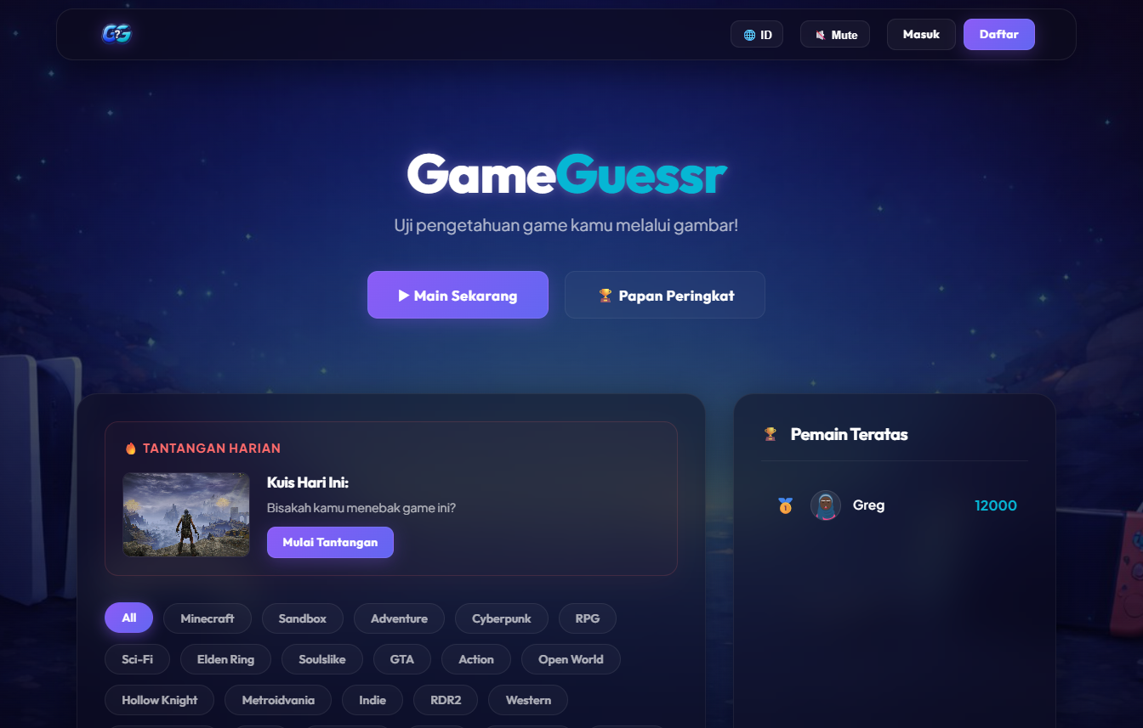
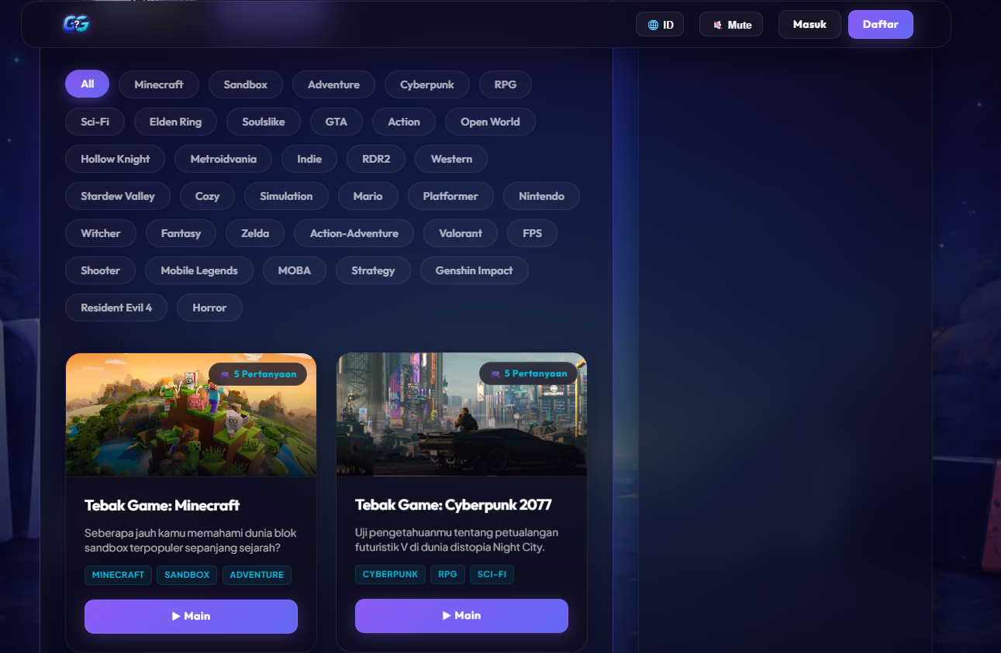
Fig 1-2. Landing Page (Guest View)

B. Registration / Login Page
- Registration form: Username (3-20 alphanumeric chars), Email (valid format), Password (min 8 chars with letter + number), Confirm Password.
- Login form: Email + Password. Real-time client-side validation with Snackbar error messages.
- Glassmorphism card design with authentication-themed background image.

Table Input (Register Page)

Field Name | Data Type | Description
Username | String | Constraint: 3-20 characters, Alphanumeric
Email | String | Valid email address format
Password | String | Constraint: Min. 8 characters, letters & numbers combined
Confirm Password | String | Must match the Password field exactly

Table Output (Register Page)

Output Information | Data Type | Description
Notification Message | String | E.g., "Account successfully created" or "Email already exists"

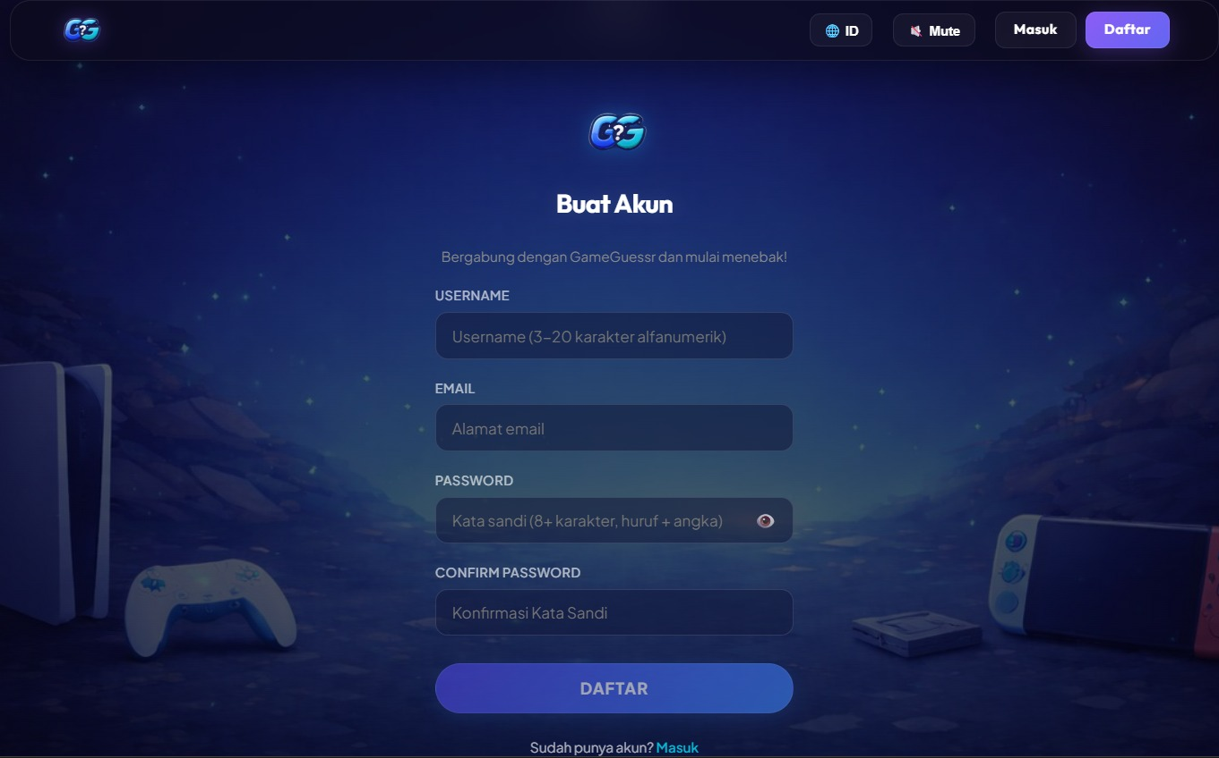
Fig 3. Register Page

Table Input (Login Page)

Field Name | Data Type | Description
Email | String | Valid email format (e.g., user@mail.com)
Password | String | User's password (masked/hidden)
Table Output (Login Page)

Output Information | Data Type | Description
Notification Message | String | Error message if failed (e.g., "Invalid credentials")
Auth Token | String | JWT Token stored in the background upon success
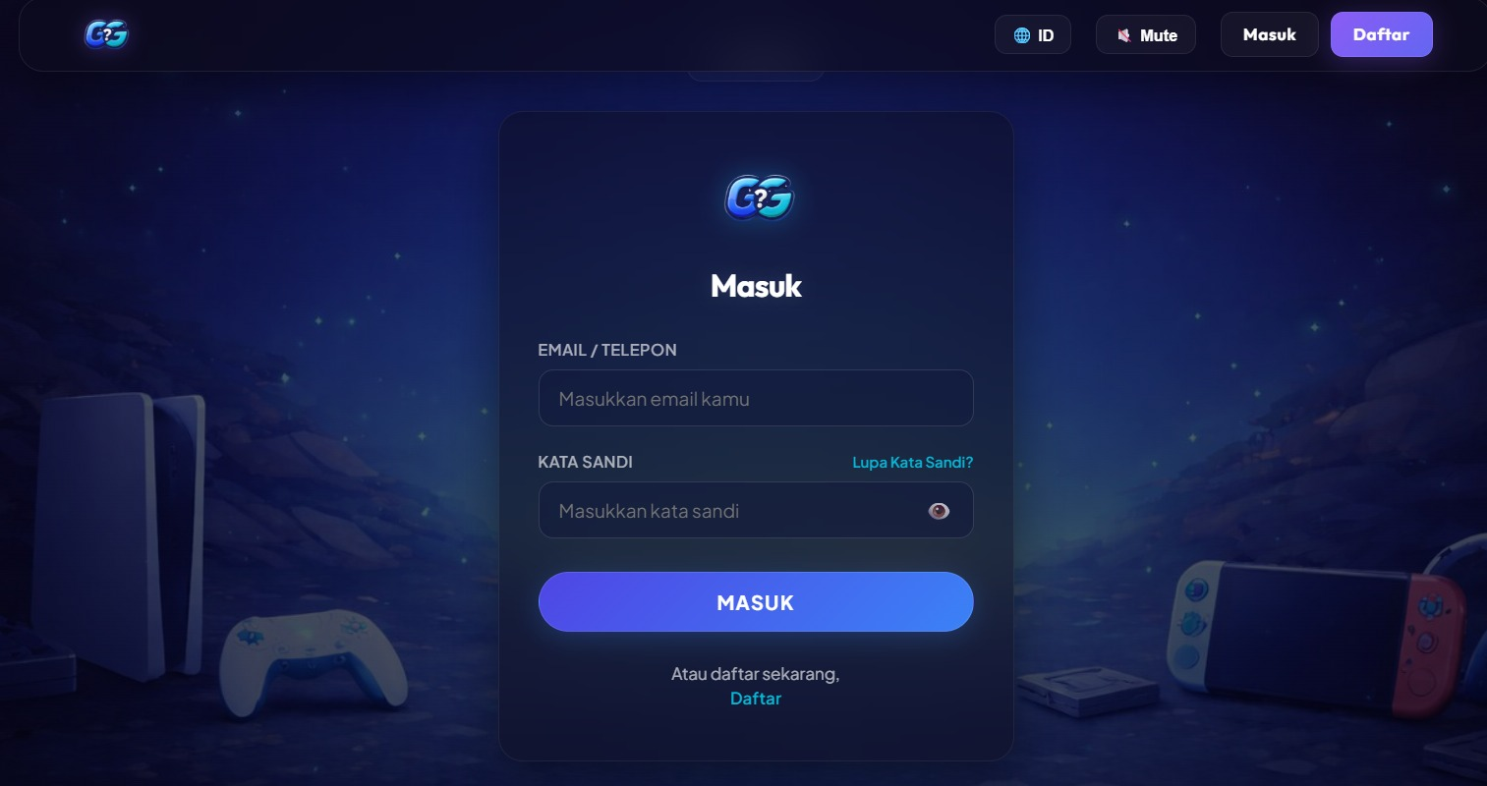
Fig 4. Login Page

C. Participant Dashboard
- Hero Section: Large "GameGuessr" title with text-glow effect, sub-headline, and action buttons ("Play Now", "Leaderboard").
- Daily Challenge: A rotating daily quiz card with cover image, description, and "Start Challenge" button.
- Category Filter Pills: Clickable pill buttons to filter quizzes by category tags (e.g., FPS, RPG, Sandbox).
- Quiz Grid: Cards showing game cover image, title, description, tags, question count, and "Play" button. Each card features glassmorphism styling with hover animations.
- Top Players Sidebar: A side panel showing the top 5 global players with avatar, display name, and total score.
- Tabs (logged-in): Toggle between "Available Quizzes" and "My Recent Activity" showing the last 5 quiz attempts with score and rank.
Table Input (Participant Dashboard)
Field Name | Data Type | Description
Tab | String | Select a quiz category (e.g., FPS, PC, RPG, etc.)
Navigation Buttons | Action | "Play Now", "Leaderboard", etc. buttons that trigger URL routes

Table Output (Participant Dashboard)

Output Information | Data Type | Description
Daily Challenge Data | Object | Contains Title (String), Image (URL), and Status
Quiz List | Array of Objects | Contains the list of available quizzes
Top Players (Leaderboard) | Array of Objects | Contains Rank (Integer), Username (String), Score (Integer), and AvatarURL (String)

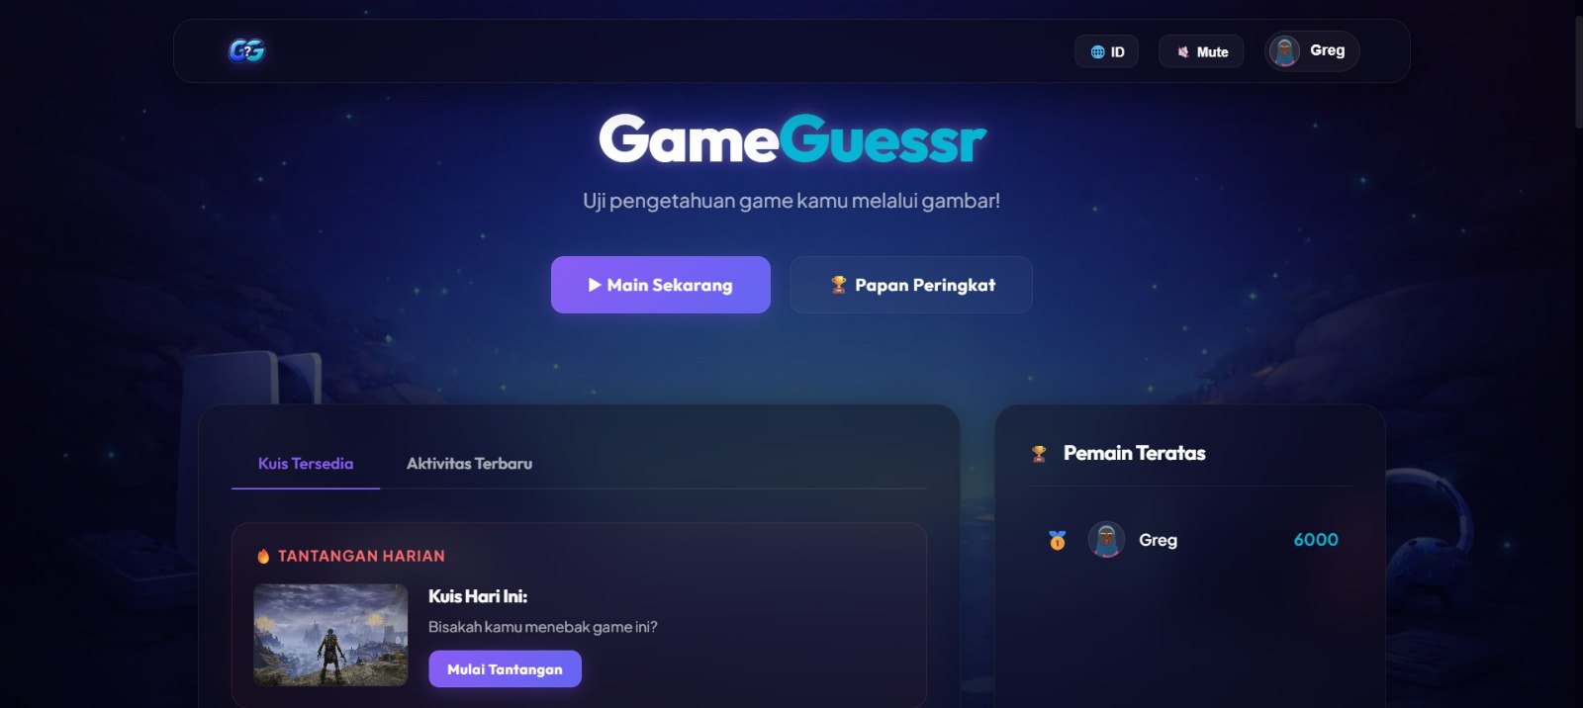
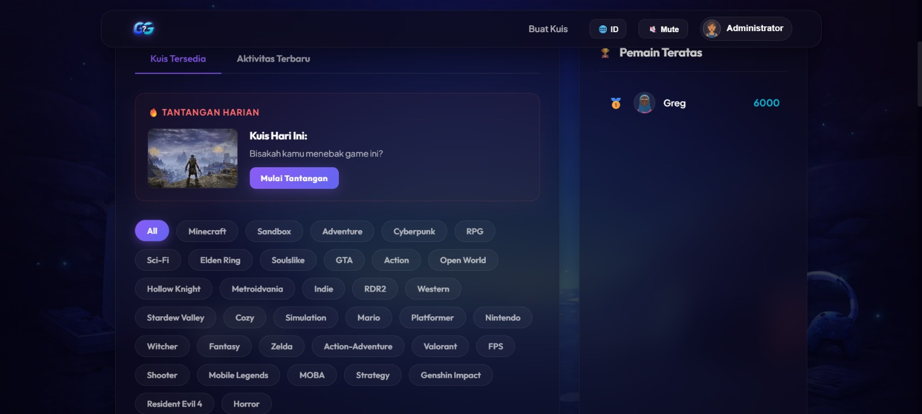
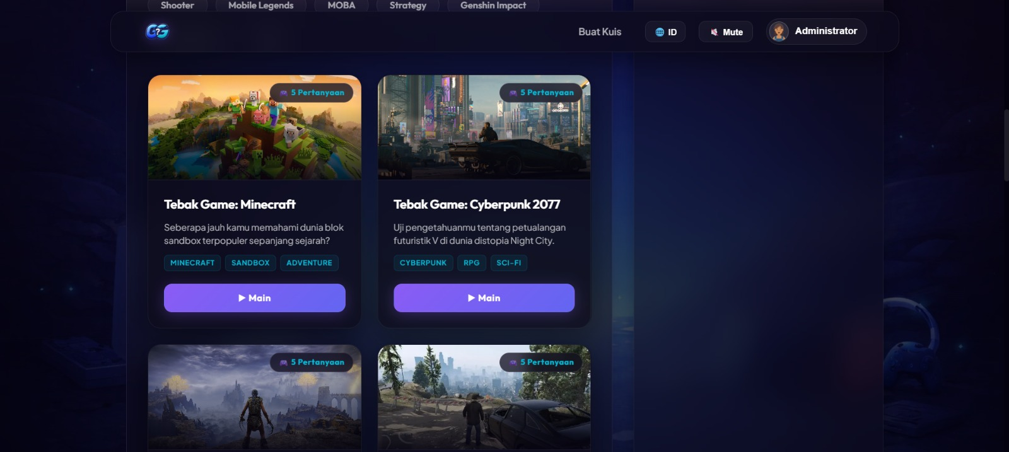
Fig 5-7. Participation Dashboard

D. Quiz Participation Interface
- Header Bar: Displays Quiz Title, current question number (e.g., “Question 5/10”), and a prominent countdown timer (format MM:SS).
- Question Area: Large, readable text for the question stem.
- Answer Options: Four radio‑button style cards (A, B, C, D). Only one may be selected.
- Action Button: “Submit Answer”. This button is disabled until an option is selected. Once submitted, the button changes to “Next Question” (or “Finish Quiz” on the last question).
- Feedback Overlay: After submitting, a green (correct) or red (incorrect) banner appears for 1.5 seconds showing the result before automatically advancing to the next question.
- Disconnection Handling: If WebSocket disconnects, a modal overlay appears: “Connection lost. Attempting to reconnect…” with a spinner. When reconnected, the quiz resumes from the last unanswered question.

Tabel Input (Quiz Page)

Field Name | Data Type | Description
Answer Selection | String / Integer | The option clicked by the user (e.g., the ID of option C "Fallout")
Tabel Output (Quiz Page)

Output Information | Data Type | Description
Question Progress | String / Integer | Current question sequence (e.g., "1 of 3")
Timer | Integer | Remaining time in seconds
Real-time Score | Integer | Current accumulated score
Question Image | Image | Reference image for the question
Question Text | String | E.g., "Which is post-apocalyptic…”
Answer Options (A,B,C,D) | Array of Strings | Text for each multiple-choice option

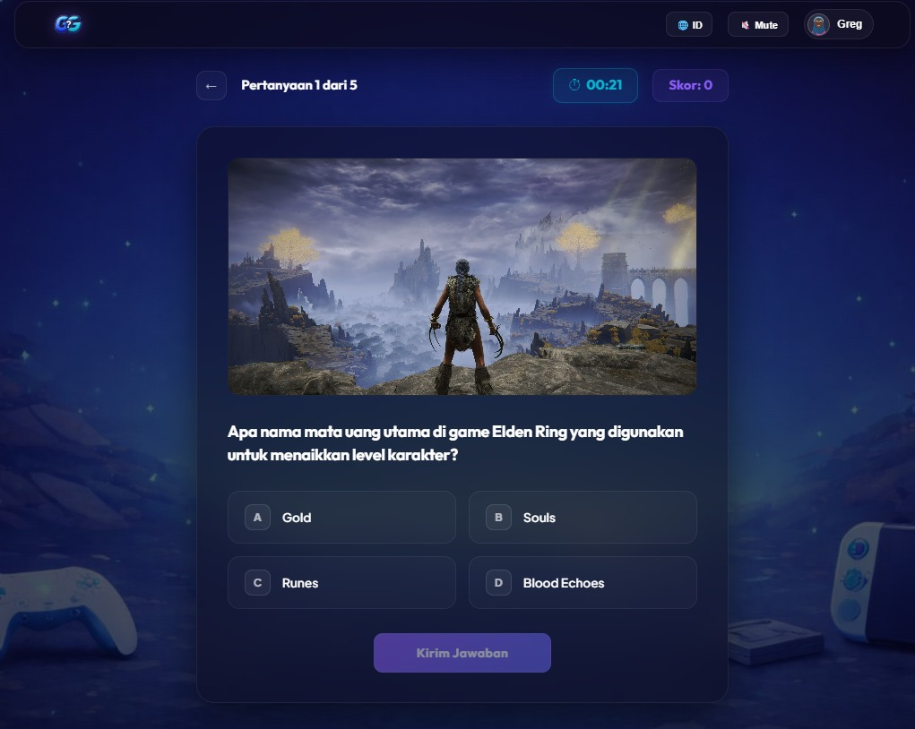
Fig 8. Quiz Page

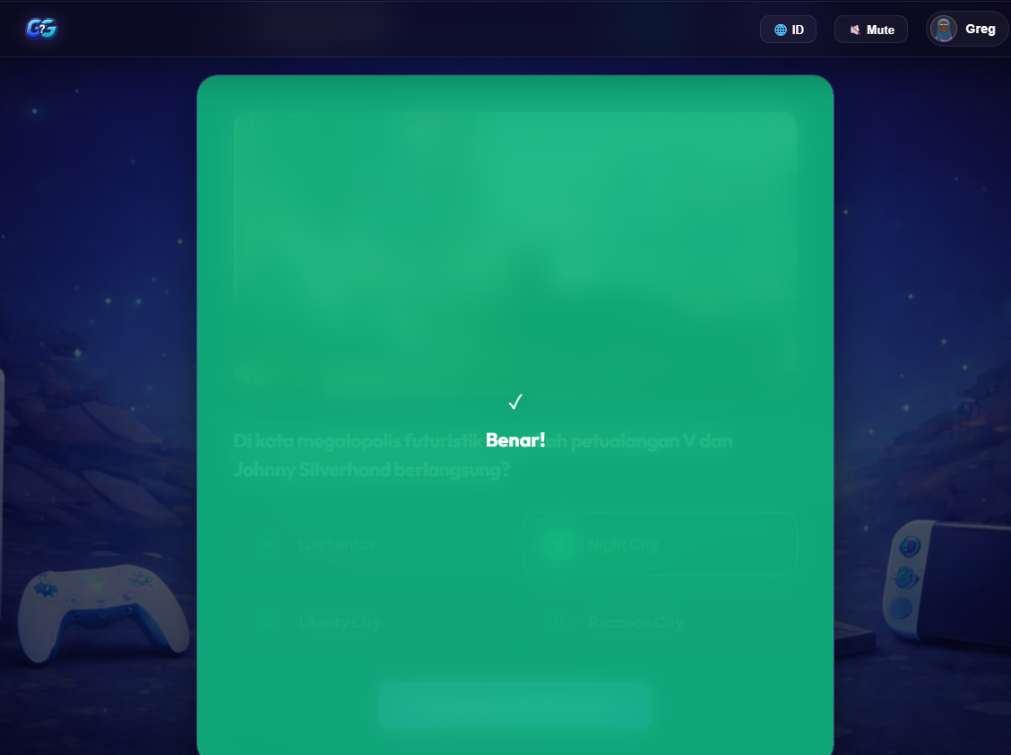
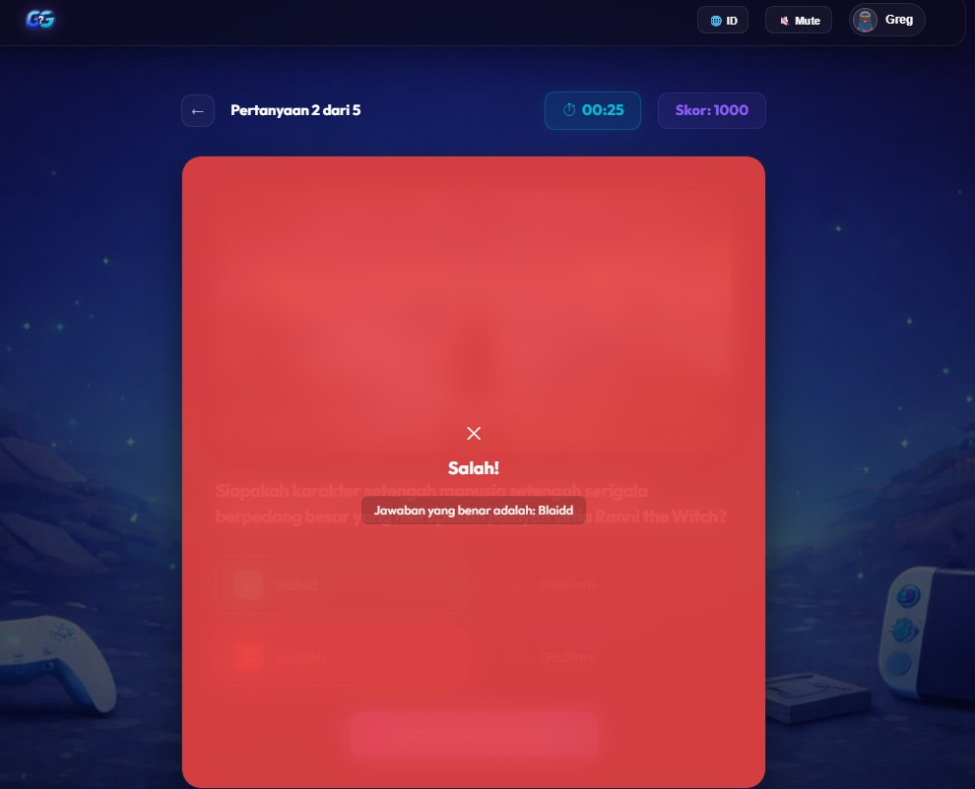
Fig 9-10. Correct/Incorrect Feedback Overlay

E. Quiz Creation Interface (Uploader)
- Step 1 – Upload: Drag‑and‑drop zone for file upload, or “Browse” button. Supported formats displayed. Progress bar during upload.
- Step 2 – Configuration: Form with fields:
  - Quiz Title (required, max 100 characters)
  - Category/Tags (comma‑separated)
  - Time per Question: Slider or dropdown (15, 30, 45, 60, 90, 120 seconds). Default 30s.
  - Number of Questions to Use (from parsed content): numeric input, max limited by number of extracted questions.
- Step 3 – Question Editor: A list of generated questions. Each row shows question text, four answer options, and a checkbox for “Correct Answer”. Uploaders can edit any field, add new question, or delete a question. A “Preview” button shows how the question will appear to participants.
- Step 4 – Publish: Summary of quiz settings. “Publish Quiz” button makes it live.

Table Input (Quiz Creation Step 1 - Upload Page)

Field Name | Data Type | Description
Game Image | File (Image) | Quiz cover image (MIME format: .jpg, .png)
Quiz Document | File (Document) | Question source document (MIME format: .txt, .pdf, .json)

Table Output (Quiz Creation Step 1 - Upload Page)

Output Information | Data Type | Description
Upload Status | String | Indicator of the successfully uploaded filename or a loading bar

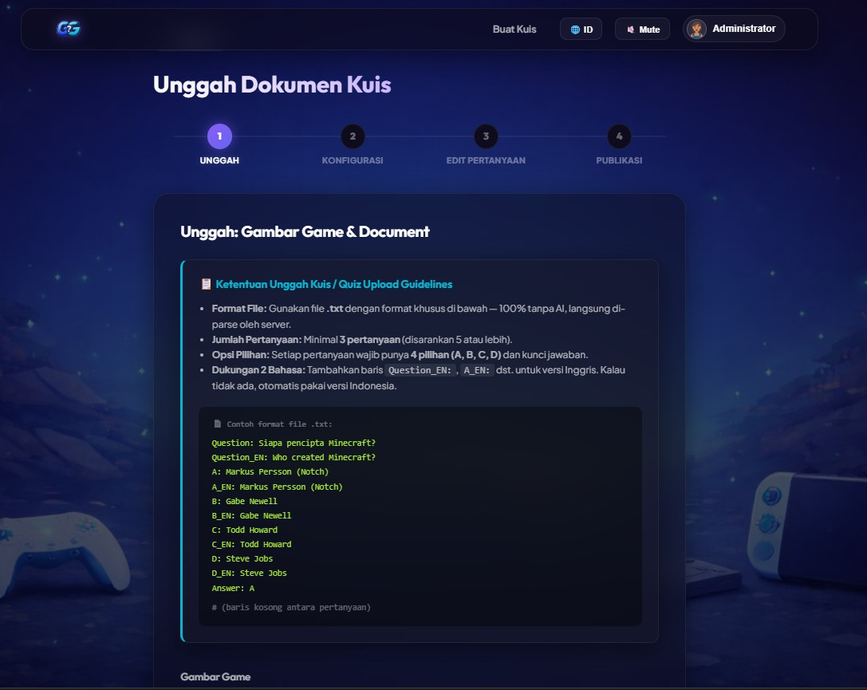
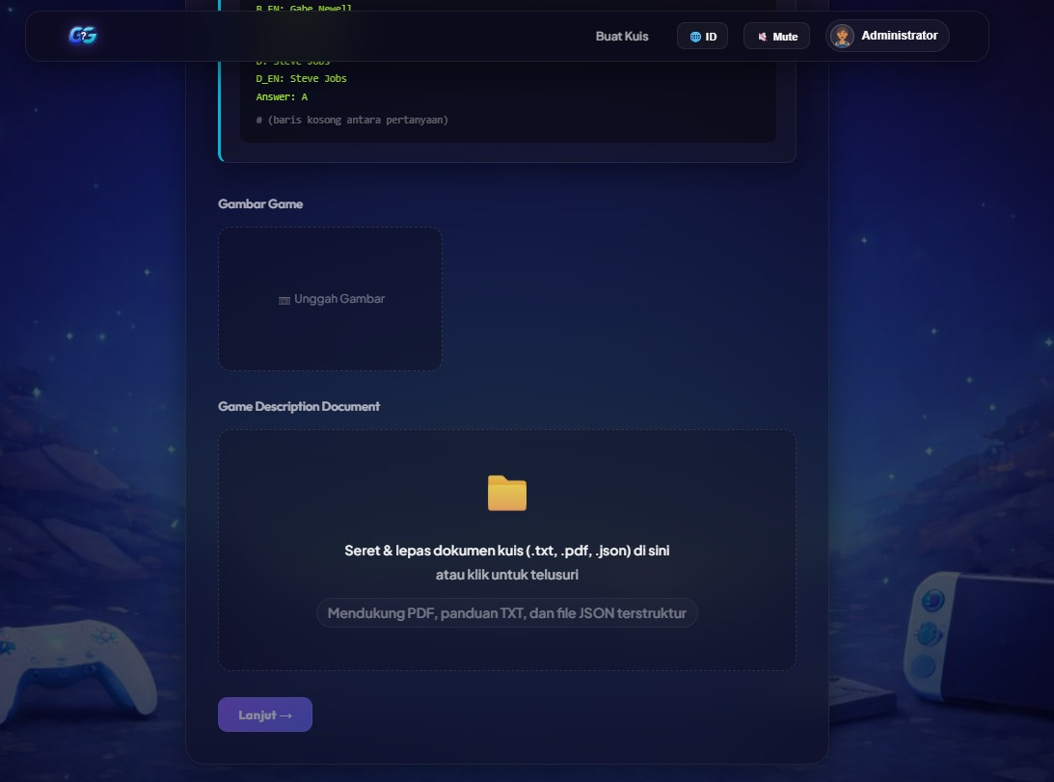
Fig 11-12. Quiz Creation Step 1 - Upload Page

Table Input (Quiz Creation Step 2 - Configure Page)

Field Name | Data Type | Description
Quiz Title | String | Title of the quiz
Description | String | Optional quiz description
Category Tags | String | Comma-separated tags (e.g., "RPG, Adventure")
Time Per Question | Integer | Input from slider in seconds (e.g., 30)
Number of Questions | Integer | Input from slider (e.g., 5)

Table Output (Quiz Creation Step 2 - Configure Page)

Output Information | Data Type | Description
Slider Values | String / Integer | Real-time display of the number as the slider is dragged (e.g., "30s")

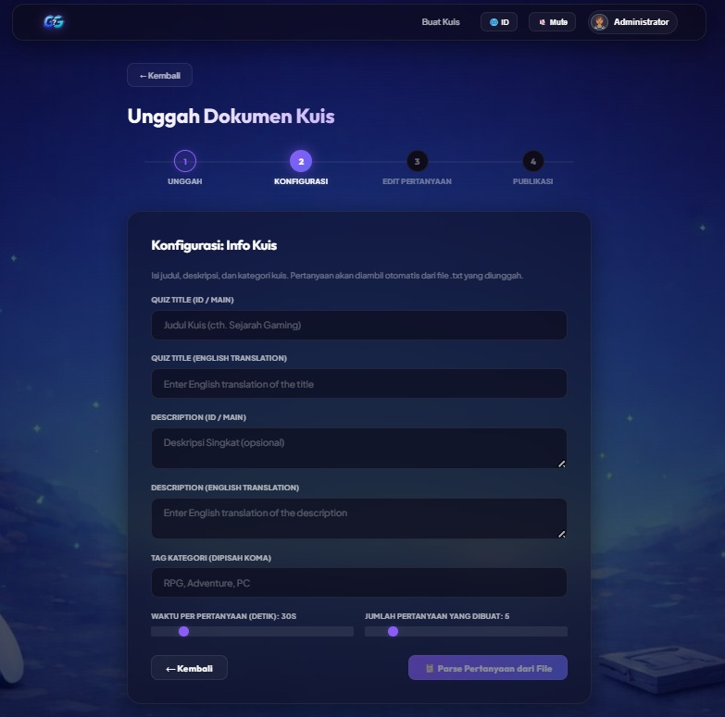
Fig 12. Quiz Creation Step 2 - Configure Page

Table Input (Quiz Creation Step 3 - Edit Questions Page)

Field Name | Data Type | Description
Question Text (Q1..) | String | Editable by the Uploader
Answer Options (A..D) | String | Editable by the Uploader
Correct Answer Key | Integer / Char | Radio/checklist selection to mark the correct answer (green outline)
Delete Action | Trigger / Event | Deletes that specific question block

Table Output (Quiz Creation Step 3 - Edit Question Page)

Output Information | Data Type | Description
Draft Question List | Array of Objects | The generated questions parsed from the PDF/TXT document in Step 1

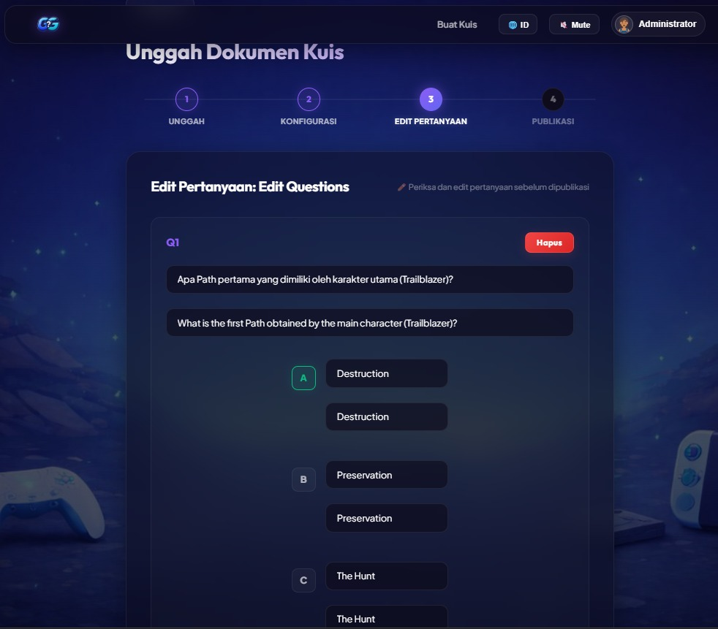
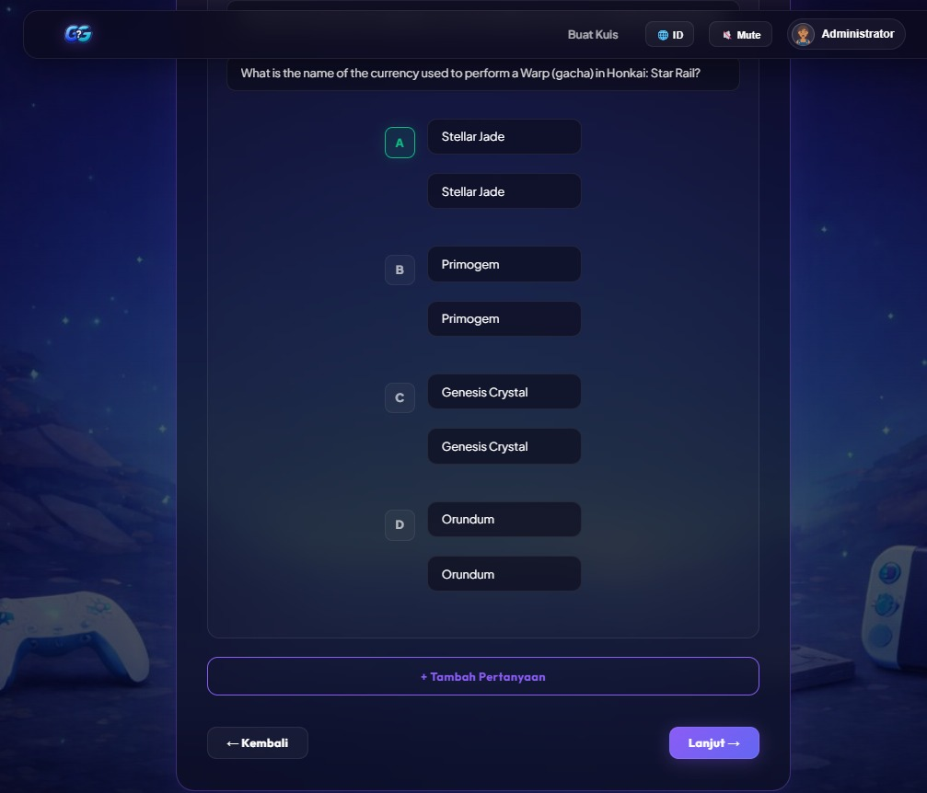
Fig 13-14. Quiz Creation Step 3 - Edit Question Page

Table Input (Quiz Creation Step 4 - Publish)

Field Name | Data Type | Description
Publish Action | Trigger / Event | Clicking the "Publish Quiz" button

Table Output (Quiz Creation Step 4 - Publish)

Output Information | Data Type | Description
Quiz Thumbnail | URL | The uploaded cover image
Quiz Metadata | Object | Contains Title (String), Uploader Name (String), Tags (Array), Total Q's (Integer), Time/Q (Integer)
Question Summary | Array of Objects | Displays the Question Text (String) and the correct Answer Key (String)
Success Message | String | Notification "Quiz Published" (triggered after clicking the publish button)

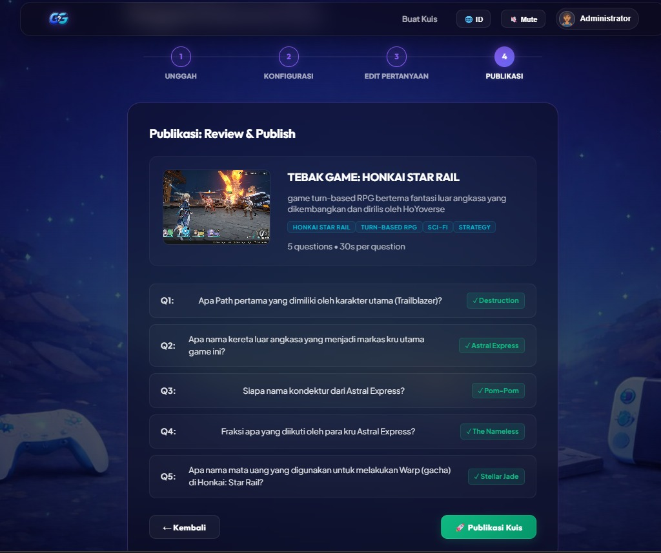
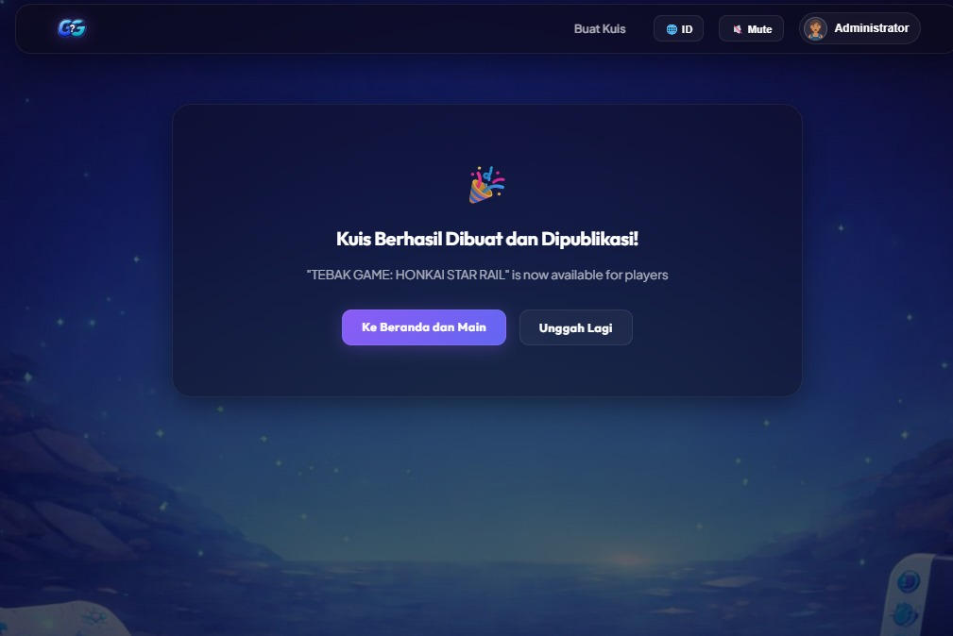
Fig 15-16. Quiz Creation Step 4 - Publish

F. Leaderboard Page
- Filters: Dropdown to select a specific quiz.
- Table: Columns: Rank (1,2,3 with medal emojis 🥇🥈🥉), Username, Score, Time Taken (in seconds).
- Personal Highlight: The logged‑in user’s row is highlighted with a light blue background.

Table Input (Leaderboard Page)

Field Name | Data Type | Description
Category Filter | String | Dropdown menu selection (e.g., selecting "Global Leaderboard" or a specific quiz)

Table Output (Leaderboard Page)

Output Information | Data Type | Description
Ranking List | Array of Objects | Sorted rows of player data
Rank | Integer | Player’s position
Player | String | Player's account name
Score | Integer | Player's accumulated points
Quizzes | Integer | Number of quizzes completed by that player

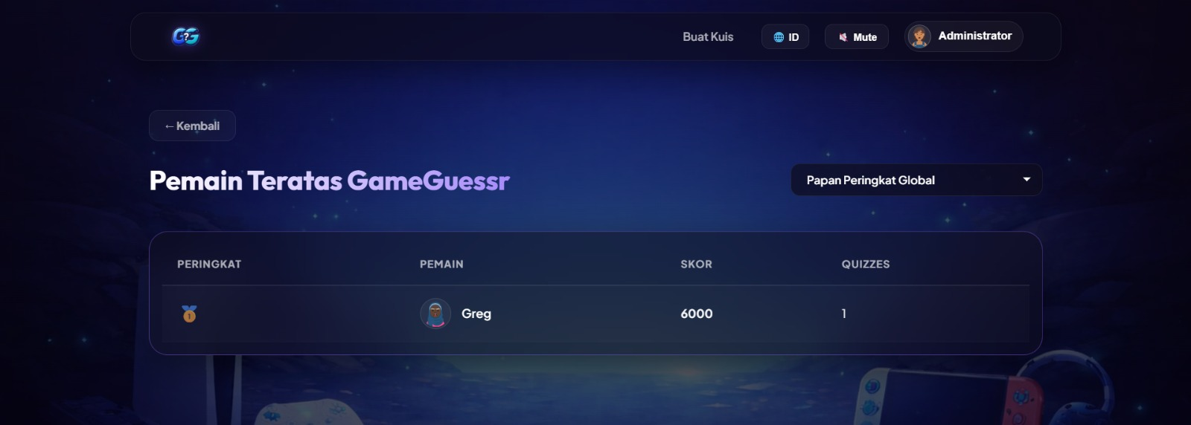
Fig 16. Leaderboard Page

G. Admin Panel (Administrator Only)
- Users Tab: Table listing all users with columns: Username, Email, Role (dropdown to change), Join Date, Actions (Delete).
- Quizzes Tab: Table of all quizzes with columns: Title, Uploader, Created Date, Status (Active/Hidden), Actions (Hide/Unhide, Delete).
- Reports Tab: Simple charts (using Chart.js) showing:
  - New user registrations per day (last 30 days)
  - Quizzes created per week
  - Average quiz score distribution.

Table Input (Admin Panel - Users Tab)

Field Name | Data Type | Description
Role Change Action | Trigger / Event | Clicking "Promosi" (Promote to Uploader) or "Turunkan" (Demote to Participant)
Delete Action | Trigger / Event | Clicking "Hapus" (Delete) to remove or soft-delete a user account

Table Output (Admin Panel - Users Tab)

Output Information | Data Type | Description
User List | Array of Objects | The fetched list of all users from the database
Username | String | The user's display name
Email | String | The user's registered email address
Role | String | Current role tag (ADMIN, UPLOADER, PARTICIPANT)
Status | Boolean / String | Active indicator (e.g., "Aktif" / Green dot)
Join Date | Date / String | Formatted date of registration (e.g., "6/2/2026")

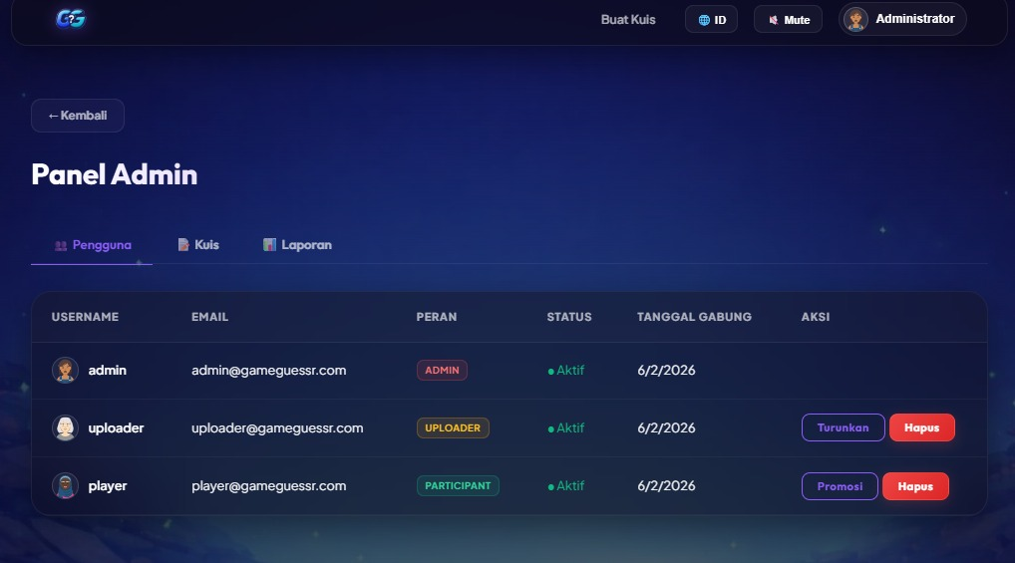
Fig 17. Admin Panel - Users Tab

Table Input (Admin Panel - Quizzes Tab)

Field Name | Data Type | Description
Hide Action | Trigger / Event | Clicking "Sembunyikan" (Hide) to remove a quiz from public view without deleting it.
Delete Action | Trigger / Event | Clicking "Hapus" (Delete) to remove or soft-delete a user account

Table Output (Admin Panel - Quizzes Tab)

Output Information | Data Type | Description
Quiz List | Array of Objects | The fetched list of all users from the database
Title | String | The name of the quiz (e.g., "Tebak Game: Minecraft").
Created By | String | The username of the Uploader who created it.
Questions | Integer | Total number of questions in that quiz (e.g., 5).
Attempts | Integer | How many times participants have played this quiz.
Status | String | Current visibility status (e.g., "PUBLISHED", "HIDDEN").

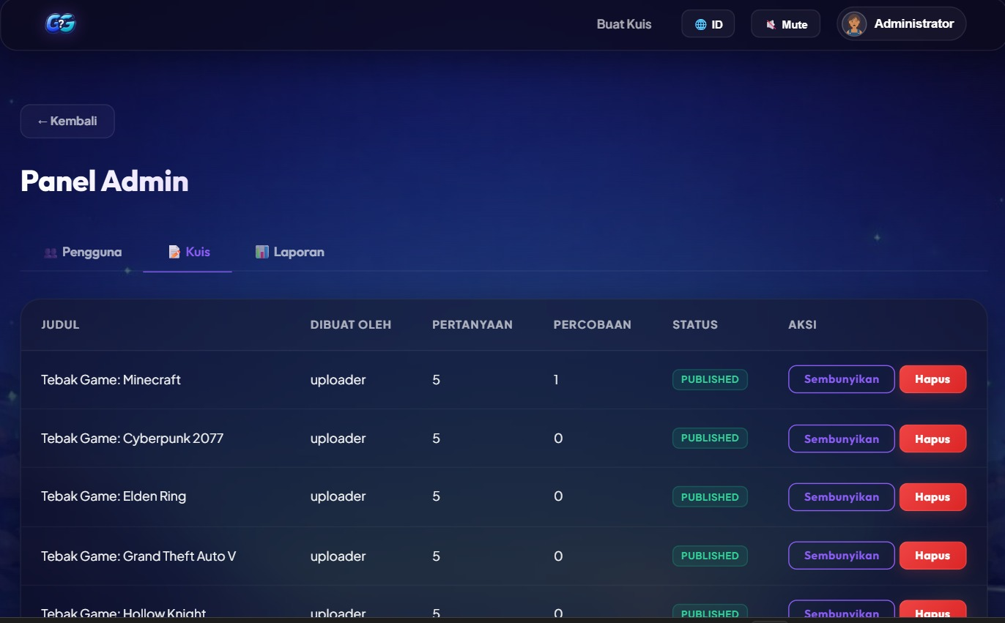
Fig 18. Admin Panel - Quizzes Tab

Table Input (Admin Panel - Reports Tab)

Field Name | Data Type | Description
Navigation | Trigger / Event | Clicking the "Laporan" tab to load the statistics.

Table Output (Admin Panel - Reports Tab)

Output Information | Data Type | Description
System Statistics | Objects | Aggregated metrics from the backend database.
Total Users | Integer | Count of all registered accounts (e.g., 3).
Total Quizzes | Integer | Count of all published quizzes (e.g., 14).
Total Attempts | Integer | Sum of all completed quiz sessions (e.g., 1).
Average Score | Integer / Float | The mean score across all attempts globally (e.g., 6000).

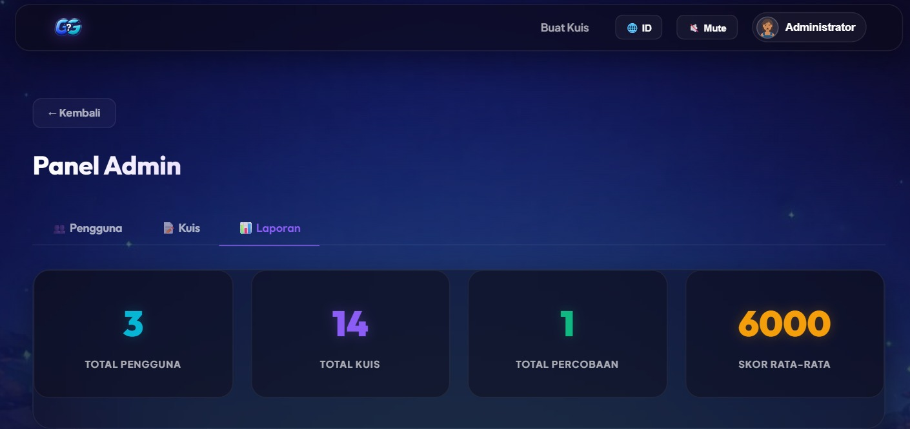
Fig 19. Admin Panel - Reports Tab

Hardware Interfaces
GameGuessr does not interface directly with any specialized hardware peripherals. It relies entirely on standard input/output devices managed by the operating system and browser.
- Input Devices: Keyboard, mouse, touchscreen (on mobile devices).
- Output Devices: Display monitor/screen, speakers/headphones (for audio feedback and background music).
- No Direct Hardware Control: The application does not access device sensors beyond what the browser sandbox permits (e.g., LocalStorage for caching preferences).

Software Interfaces
This section details the interfaces between GameGuessr and external software components or libraries.
3.3.1 Database Interface – MySQL
Attribute | Description
DBMS | MySQL 8.4
Connection Method | mysql2 Node.js driver (promise‑based)
Connection Pool | connectionLimit: 20, waitForConnections: true, charset: utf8mb4
Authentication | Username/password stored in environment variables. No hard‑coded credentials.
Data Exchange | SQL queries and result sets. Parameterized queries used exclusively to prevent SQL injection.
Port | 3306 (default, internal network only)

3.3.2 File System Interface
Attribute | Description
Storage Location | /uploads/ (content files), /uploads/games/ (cover images)
File Naming | {timestamp}-{original_filename} to prevent collisions
Access | Uploaded files are served statically via Express static middleware
Size Limit | 10 MB per file (enforced by Multer)

3.3.3 Third‑Party Libraries (NPM)
All libraries are managed via package.json. Key runtime dependencies:
Library | Version | Interface Description
express | 4.19.2 | Provides HTTP server and middleware routing.
socket.io | 4.7.5 | Attaches to the HTTP server to provide WebSocket functionality. Exports io object for event handling.
jsonwebtoken | 9.0.2 | jwt.sign() and jwt.verify() used for token management.
bcryptjs | 2.4.3 | bcryptjs.hash() and bcryptjs.compare() for password handling.
multer | 1.4.5 | Middleware for handling multipart/form-data file uploads.
pdf‑parse | 1.1.1 | Function pdf(dataBuffer) returns a promise with text content.
mammoth | 1.6.0 | mammoth.extractRawText({ buffer }) returns a promise with text.
express‑rate-limit | 7.2.0 | Middleware for validating and sanitizing request bodies.
helmet | 7.1.0 | Sets various HTTP headers for security.
cors | 2.8.5 | Configures Cross‑Origin Resource Sharing for API endpoints.
3.3.4 Frontend Dependencies
Library | Version | Interface Description
react | 19.2.6 | Core UI library.
react‑router‑dom | 7.15.0 | Client‑side routing.
lucide-react | 1.14.0 | Provides clean, lightweight, and customizable SVG vector icons as React components

Communications Interfaces
3.4.1 REST API over HTTPS
- Protocol: HTTP (HTTPS in production with TLS 1.2+).
- Base URL: http://localhost:5000/api (development)
- Authentication: All endpoints except /auth/register and /auth/login require a valid JWT in the Authorization: Bearer <token> header.
- Request/Response Format: JSON (Content-Type: application/json).
- Rate Limiting: Implemented using express-rate-limit. Default: 100 requests per IP per 15 minutes.
3.4.2 WebSocket Communication (Socket.io)
- Protocol: WSS (WebSocket Secure) over the same port as HTTPS (443).
- Connection URL: wss://api.GameGuessr.app/socket.io/
- Authentication: The Socket.io connection is authenticated using the same JWT sent as a query parameter or in the auth handshake object.
- Namespaces / Rooms:
  - Each quiz session is mapped to a Socket.io room named quiz:{quizId}:{sessionId}.
  - Participants join the room upon starting a quiz.
  - The server emits events to the room to synchronize timers and advance questions.
- Event Schema (Server → Client):
  - question:new – payload: { questionId, text, options, timeLimit, questionNumber, totalQuestions }
  - timer:sync – payload: { remainingSeconds } (sent every second)
  - answer:result – payload: { correct, correctAnswerId, scoreDelta }
  - quiz:completed – payload: { finalScore, totalQuestions, leaderboardRank }
  - error – payload: { code, message }
- Event Schema (Client → Server):
  - answer:submit – payload: { questionId, answerId }
  - quiz:leave – payload: { } (graceful disconnect)
3.4.3 Email Communication (Optional for MVP)
- Purpose: Send account verification and password reset emails.
- Implementation: If implemented, the system will use Nodemailer with an SMTP relay (e.g., SendGrid, AWS SES).
- Message Format: HTML emails with a plain‑text fallback.
- Security: All links in emails will use HTTPS and include a time‑limited, single‑use token.

System Features

This section organizes functional requirements by major features. Each requirement is uniquely identified and prioritized.

Authentication and Authorization
4.1.1 Description and Priority
This feature manages user identity, session management, and access control based on roles. It is the foundational security component of GameGuessr.
Priority: High – Without it, no other features can function securely.
4.1.2 Stimulus/Response Sequences
Actor | Action | System Response
Guest | Submits registration form with valid data. | 1. Validates input.  2. Checks email/username uniqueness.  3. Hashes password (bcryptjs, salt factor 10).  4. Inserts user record with role 'participant'.  5. Returns 201 Created with JWT token and user info.
Guest | Submits registration with existing email. | Returns 400 Bad Request with error "Email already exists".
User | Submits login form with valid credentials. | 1. Finds user by email.  2. Compares password with bcryptjs.  3. Generates JWT (expires in 24h).  4. Returns 200 OK with token and user profile.
User | Submits login with invalid credentials. | Returns 401 Unauthorized: "The email or password you entered is incorrect."
User | Logs out. | Client discards JWT from localStorage. Server does not maintain state.
Participant | Attempts to access the admin endpoint. | Server middleware checks role claim in JWT. Returns 403 Forbidden if role ≠ admin.
Admin | Promotes a user to Uploader. | 1. Validates admin token.  2. Updates user's role to 'uploader'.  3. Logs action in audit_log.  4. Returns 200 OK.
4.1.3 Functional Requirements
- REQ-AUTH-001 [High]: The system shall provide an endpoint POST /api/auth/register that accepts username, email, and password.
- REQ-AUTH-002 [High]: The system shall enforce that the username is unique, alphanumeric, and between 3 and 20 characters.
- REQ-AUTH-003 [High]: The system shall enforce that email is a valid email format and unique.
- REQ-AUTH-004 [High]: The system shall enforce that the password is at least 8 characters long and contains at least one letter and one number.
- REQ-AUTH-005 [High]: The system shall hash all user passwords using bcryptjs with a salt factor of 10 before storage.
- REQ-AUTH-006 [High]: The system shall provide an endpoint POST /api/auth/login that accepts email and password and returns a signed JWT.
- REQ-AUTH-007 [High]: The JWT payload shall include userId, username, email, role, avatar_url, and display_name. The token shall expire after 24 hours.
- REQ-AUTH-008 [High]: All protected API endpoints shall require a valid JWT in the Authorization header. Missing or invalid tokens shall result in 401 Unauthorized.
- REQ-AUTH-009 [High]: The system shall implement role-based middleware: requireAuth (any authenticated user), requireUploader (uploader or admin), requireAdmin (admin only).
- REQ-AUTH-010 [High]: The system shall provide GET /api/auth/me to retrieve the current user's profile information.
- REQ-AUTH-011 [High]: The system shall provide PATCH /api/auth/profile to update display_name and avatar_url, returning a new JWT with updated claims

Uploader Module - Content Upload and Quiz Configuration
4.2.1 Description and Priority
This feature enables users with the Uploader role to submit content files, have them parsed into quiz questions, configure quiz parameters, and publish the quiz for participants.
Priority: High – Content is the fuel for the platform.
4.2.2 Stimulus/Response Sequences
Actor | Action | System Response
Uploader | Uploads a valid .txt file. | 1. Saves file temporarily.  2. Extracts text.  3. Parses with parseStructuredText().  4. Returns parsed questions to the frontend editor.
Uploader | Uploads a .pdf file. | 1. Extracts text with pdf-parse.  2. Parses extracted text.  3. Returns parsed questions.
Uploader | Uploads a .docx file. | 1. Extracts text with mammoth.  2. Parses extracted text.  3. Returns parsed questions.
Uploader | Uploads a .json file. | 1. Parses JSON directly.  2. Maps to question objects.  3. Returns questions.
Uploader | Uploads a file larger than 10 MB. | Multer rejects file. Returns 413 Payload Too Large.
Uploader | Clicks "Publish Quiz" after configuring. | 1. Validates title and ≥1 question.  2. Saves quiz and questions to database.  3. Returns 201 Created with quizId.
4.2.3 Functional Requirements
File Upload & Parsing
- REQ-UPLOAD-001 [High]: The system shall accept file uploads via POST /api/upload/upload with multipart/form-data. Supported formats: .txt, .pdf, .docx, .json.
- REQ-UPLOAD-002 [High]: The system shall enforce a maximum file size of 10 MB.
- REQ-UPLOAD-003 [High]: For .txt files, the system shall apply a structured text parser that extracts Question/A/B/C/D/Answer fields (including bilingual _EN variants).
- REQ-UPLOAD-004 [Medium]: The system shall allow Uploaders to upload a JSON file with directly defined questions.
- REQ-UPLOAD-005 [High]: The system shall provide POST /api/upload/create that accepts title, description, categoryTags, timePerQuestion, questions, and optional gameImage.
- REQ-UPLOAD-006 [High]: Each question object shall contain questionText, options (A/B/C/D), correctOption, and optional _EN bilingual variants.
- REQ-UPLOAD-007 [High]: The system shall allow Uploaders to upload a game cover image via POST /api/upload/image (JPEG, PNG, GIF, WebP).
- REQ-UPLOAD-008 [High]: Upon successful quiz creation, the system shall store the quiz record with status = 'published' and created_by = userId

Quiz Module - Real‑Time Quiz Session Management
4.3.1 Description and Priority
This feature delivers timed, sequential questions to participants, records answers in real time, calculates scores, and manages the lifecycle of a quiz session.
Priority: High – This is the core interactive experience.
4.3.2 Stimulus/Response Sequences (Detailed)4.3.3 Functional Requirements
- REQ-QUIZ-001 [High]: The system shall allow an authenticated participant to start a quiz and receive randomized questions via GET /api/quizzes/:id/questions.
- REQ-QUIZ-002 [High]: Questions shall be returned in a random order (ORDER BY RAND()) unique to each request to reduce cheating.
- REQ-QUIZ-003 [High]: The system shall support bilingual question display (ID/EN) controlled by a ?lang= query parameter.
- REQ-QUIZ-004 [High]: The frontend shall maintain a per-participant countdown timer based on the quiz time_limit.
- REQ-QUIZ-005 [High]: When the timer reaches zero without an answer, the system shall automatically treat the answer as incorrect and advance to the next question.
- REQ-QUIZ-006 [High]: Upon submitting an answer, the system shall compare the selected option with correct_option and calculate the score (+1,000 points per correct answer).
- REQ-QUIZ-007 [High]: The system shall show immediate visual feedback (green/red overlay) and audio feedback after each answer.
- REQ-QUIZ-008 [High]: The system shall display a streak combo animation for ≥3 consecutive correct answers.
- REQ-QUIZ-009 [High]: Upon answering the last question, the system shall submit the score via POST /api/quizzes/:id/submit.
- REQ-QUIZ-010 [High]: The system shall prevent a participant from submitting a score for a quiz they already completed (UNIQUE KEY on user_id + quiz_id).
- REQ-QUIZ-011 [High]: The system shall prevent a participant from playing a quiz they created.
- REQ-QUIZ-012 [High]: The system shall provide GET /api/quizzes/:id/check to verify if a user has already completed a specific quiz.

  - Leaderboard Module – Scoring and Ranking
4.4.1 Description and Priority
This feature computes and displays rankings for each quiz and provides participants with historical performance data.
Priority: High – Essential for the competitive, gamified experience.
4.4.2 Functional Requirements
- REQ-LEAD-001 [High]: The system shall provide GET /api/quizzes/:id/leaderboard that returns a sorted list of participants with username, score, time_taken, and avatar.
- REQ-LEAD-002 [High]: The leaderboard shall be sorted by score descending. In case of a tie, the participant with lower time_taken ranks higher.
- REQ-LEAD-003 [High]: The system shall provide GET /api/quizzes/leaderboard/global that returns the top 50 players across all quizzes with total_score, quizzes_taken, and avg_score.
- REQ-LEAD-004 [High]: The system shall provide GET /api/quizzes/history/me that returns the authenticated user's quiz history and summary statistics (total_quizzes, avg_score, highest_score, total_score).
- REQ-LEAD-005 [High]: The top three participants on any leaderboard shall receive visual medal indicators (🥇🥈🥉).
- REQ-LEAD-006 [Medium]: The system shall highlight the current user's row in the leaderboard table.

  - Administrative Control Panel
4.5.1 Description and Priority
This feature provides system administrators with tools to manage users, moderate content, and monitor system health.
Priority: Medium – Not required for initial participant engagement, but critical for long‑term operation.
4.5.2 Functional Requirements
User Management
- REQ‑ADMIN‑001 [High]: The system shall provide GET /api/admin/users (admin only) that returns a paginated list of all users with filters by role and search by username/email.
- REQ‑ADMIN‑002 [High]: The system shall provide PATCH /api/admin/users/:userId that allows an admin to update a user's role (to 'participant' or 'uploader'). Admin roles cannot be changed.
- REQ‑ADMIN‑003 [Medium]: The system shall provide DELETE /api/admin/users/:userId that soft-deletes a user account (sets is_active = 0). Admin accounts cannot be deleted.
Content Moderation
- REQ‑ADMIN‑004 [High]: The system shall provide an endpoint GET /admin/quizzes with filters by status and uploader.
- REQ‑ADMIN‑005 [High]: The system shall allow an admin to hide a quiz via PATCH /admin/quizzes/:quizId with body { status: 'hidden' }. Hidden quizzes do not appear in participant dashboards but remain in the database.
- REQ‑ADMIN‑006 [Medium]: The system shall allow an admin to permanently delete a quiz and all associated scores via DELETE /admin/quizzes/:quizId.
Reporting
- REQ‑ADMIN‑007 [Low]: The system shall provide an endpoint GET /admin/stats that returns:
  - Total registered users
  - Total quizzes created
  - Total quiz attempts
  - Average score across all attempts
  - New users per day (last 7 days)
- REQ‑ADMIN‑008 [Medium]: All administrative actions (role change, user deactivation, quiz status change, quiz deletion) shall be logged in the audit_log table with admin_id, action, target_type, target_id, and timestamp.

Other Nonfunctional Requirements

Performance Requirements

ID | Requirement | Priority | Measurement Method
PERF‑01 | The landing page shall load and become interactive within 2.0 seconds on a 4G network (simulated). | High | Lighthouse performance score ≥90, First Contentful Paint <1.5s.
PERF‑02 | REST API response time (95th percentile) shall be ≤300 ms under a load of 50 concurrent users. | High | k6 load test against /quizzes endpoint.
PERF‑03 | WebSocket question:new latency (server emit to client receipt) shall be ≤200 ms for 95% of events. | High | Instrumented client logging.
PERF‑04 | The system shall support 100 concurrent WebSocket connections (active quiz participants) without exceeding 70% CPU utilization on the server. | High | Load test with Artillery.
PERF‑05 | Database queries for leaderboard retrieval (top 50) shall execute in ≤100 ms. | Medium | MySQL EXPLAIN and query profiling.

Safety Requirements
- SAFE-01 [High]: All communication between client and server shall be encrypted using TLS in production.
- SAFE-02 [High]: Passwords shall never be logged or transmitted in plaintext. They are hashed using bcryptjs (cost factor 10).

Security Requirements
- SEC-01 [High]: All communication between client and server shall be encrypted using TLS in production.
- SEC-02 [High]: Passwords shall never be logged or transmitted in plaintext. They are hashed using bcryptjs (cost factor 10).
- SEC-03 [High]: JWTs shall be signed using the HS256 algorithm with a secret key stored in environment variables.
- SEC-04 [High]: The application shall set secure HTTP headers using Helmet.js.
- SEC-05 [High]: All SQL queries use parameterized statements via mysql2/promise to prevent SQL injection.
- SEC-06 [Medium]: Rate limiting is applied to authentication endpoints.

Software Quality Attributes

Attribute | Requirement | Verification Method
Usability | A first-time participant shall be able to register, find a quiz, and complete it within 5 minutes without external help. | Usability testing with 5 representative users.
Reliability | The system shall have an uptime of 99.5% during peak hours (9am–9pm) excluding scheduled maintenance. | Uptime monitoring tool.
Maintainability | The backend code shall follow route-based architecture with clear separation of concerns. | Code review checklist.
Scalability | The WebSocket layer shall be designed to be extractable into a separate service using Redis adapter in future phases. | Architecture review.
Testability | Each REST endpoint shall have at least one integration test covering success and failure scenarios. | Jest test suite coverage report (target >80%).

Business Rules
- BR-01: A user may only submit one score per quiz. Implemented via UNIQUE KEY (user_id, quiz_id) constraint on the scores table.
- BR-02: The default role for all new registered users is "participant".
- BR-03: The top three participants on any leaderboard shall receive visual medal indicators (🥇🥈🥉).
- BR-04: 14 default game quizzes are pre-seeded into the database via the seeder script (node src/config/seed.js), each with 5 bilingual questions and corresponding cover images.
- BR-05: A quiz creator (Uploader) cannot participate in their own quiz.
- BR-06: Guest users cannot play quizzes - they are redirected to the login page.

Other Requirements

6.1 Pre-Seeded Quiz Content
The system ships with 14 pre-seeded game quizzes, each containing 5 bilingual (Indonesian + English) multiple-choice questions. These quizzes cover various game categories including FPS, RPG, Sandbox, Racing, Simulation, Battle Royale, MOBA, Adventure, Horror, Sports, Rhythm, and Fighting games. Each quiz includes a corresponding cover image stored in uploads/games/

6.2 Audio Assets
All audio files are stored in FrontEnd/public/audio/ and are royalty-free:
- correct.mp3 – Played when the user selects the correct answer
- wrong.mp3 – Played when the user selects the wrong answer
- bgm.mp3 – Background music loop during quiz gameplay

6.3 Quiz Upload File Format (.txt)
The structured .txt format is parsed by the server without any AI or external API:

Question: Siapa pencipta Minecraft?
Question_EN: Who created Minecraft?
A: Markus Persson (Notch)
A_EN: Markus Persson (Notch)
B: Gabe Newell
B_EN: Gabe Newell
C: Todd Howard
C_EN: Todd Howard
D: Steve Jobs
D_EN: Steve Jobs
Answer: A

Notes:
- Minimum 3 questions per quiz (5+ recommended).
- Each question must have exactly 4 options (A, B, C, D) and a correct answer key.
- The _EN fields are optional — if omitted, the Indonesian version is used for both languages.
- Supported keywords: Question/Q/Pertanyaan (and _EN variants), A/B/C/D (and _EN), Answer/Kunci/Ans/Jawaban.
Appendix A: Glossary
Term | Definition
API | Application Programming Interface – a set of protocols for building software applications.
bcrypt | A password-hashing function designed to be computationally expensive, making brute-force attacks difficult.
CORS | Cross-Origin Resource Sharing – a mechanism that allows restricted resources to be requested from another domain.
CRUD | Create, Read, Update, Delete – the four basic operations on persistent data.
DOCX | Microsoft Word document format (.docx) using Open XML standard.
Express | A minimal and flexible Node.js web application framework for building REST APIs.
Glassmorphism | A UI design trend featuring semi-transparent, frosted-glass-like elements.
Helmet | An Express middleware that sets various HTTP headers for security.
i18n | Internationalization – the process of designing software for multiple languages.
JWT | JSON Web Token – a compact token format used for secure information transmission.
Multer | A Node.js middleware for handling multipart/form-data file uploads.
MVP | Minimum Viable Product – a version with just enough features to be usable.
MySQL | An open-source relational database management system.
PDF | Portable Document Format – a file format for presenting documents.
React | A JavaScript library for building user interfaces.
REST | Representational State Transfer – an architectural style for web services.
SDLC | Software Development Life Cycle.
Snackbar | A brief pop-up notification at the bottom of the screen.
Socket.io | A library for real-time, bidirectional, event-based communication.
SPA | Single-Page Application – a web app that loads a single HTML page and dynamically updates.
SRS | Software Requirements Specification.
TLS | Transport Layer Security – a cryptographic protocol for secure communications.
UUID | Universally Unique Identifier.
Vite | A next-generation build tool for frontend development.
WebSocket | A communication protocol providing full-duplex channels over a single TCP connection.

Appendix B: Analysis Models
B.1 USE CASE DIAGRAM

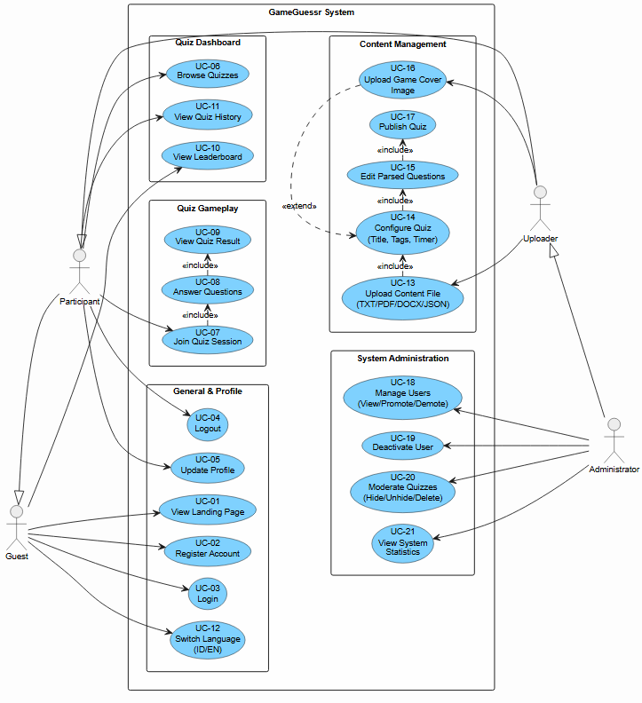

UC-01 - View Landing Page
Use Case ID | UC-01
Use Case Name | View Landing Page
Action(s) | Guest
Description | Guest can view the main page of the GameGuesser system which contains general information about the platform
Preconditions | - User opens the GameGuesser system URL  - The system is active and accessible .
Main Flow | - Guest accesses the GameGuesser system URL .  - The system displays the landing page.  - The page displays general information: platform description, featured highlights, and buttons for login/register.  - Guest can view the landing page content without needing to log in.
Alternative Flow | - If the server is unavailable, the system displays a connection error message.
Postconditions | The landing page is successfully displayed to the Guest.
Includes | -
Excludes | -

UC-02 - Register Account
Use Case ID | UC-02
Use Case Name | Register Account
Action(s) | Guest, Participant
Description | Guest can register a new account on the GameGuesser system to become a Participant.
Preconditions | - User does not have an account on the system yet.  - User is on the landing page or the register page.
Main Flow | - Guest selects the 'Register' option on the page.  - The system displays the registration form (name, email, password, password confirmation).  - Guest fills in all the required data.  - The system validates the entered data.  - The system saves the new account data into the database.  - The system displays a successful registration notification.  - User is directed to the login page.
Alternative Flow | 4a. If the email is already registered, the system displays the message 'Email already in use'.  4b. If the password does not match the confirmation, the system displays an error message.  4c. If there is an empty field, the system displays a validation message.
Postconditions | A new account is successfully created and saved in the database.  User can log in using the newly registered account
Includes | -
Excludes | -

UC-03 - Login
Use Case ID | UC-03
Use Case Name | Login
Action(s) | Guest, Participant, Uploader, Administrator
Description | Registered users can log into the system using valid credentials.
Preconditions | - User already has a registered account.  - User is not currently logged in.
Main Flow | - User accesses the login page.  - The system displays the login form (email and password)  - User enters their email and password.  - The system verifies the user's credentials.  - The system authenticates the user and creates a login session.  - The system directs the user to the main page according to their role.
Alternative Flow | 4a. If the email or password is incorrect, the system displays the message 'Invalid email or password'.  4b. If the account is deactivated, the system displays the message 'Your account has been deactivated'.
Postconditions | User successfully logs in and an active session is created.  User is directed to the dashboard according to their role.
Includes | -
Excludes | -

UC-04 - Logout
Use Case ID | UC-04
Use Case Name | Logout
Action(s) | Participant, Uploader, Administrator
Description | A logged-in user can log out of the system to end their active session.
Preconditions | - User is already logged in.  - User has an active session in the system.
Main Flow | - User selects the 'Logout' option from the menu.  - The system removes the user's active session.  - The system directs the user back to the landing page or login page.
Alternative Flow | - If the session has already expired, the system automatically directs the user to the login page.
Postconditions | The user's session is successfully removed.  User cannot access pages that require authentication.
Includes | -
Excludes | -

UC-05 - Update Profile
Use Case ID | UC-05
Use Case Name | Update Profile
Action(s) | Participant
Description | Participant can update their account profile information such as name, profile picture, and other personal data.
Preconditions | - User has logged in as a Participant.  - User is on the profile page.
Main Flow | - Participant accesses the 'Profile' menu.  - The system displays the existing profile information.  - Participant selects the 'Edit Profile' option.  - Participant modifies the data they wish to update (name, photo, etc.).  - Participant saves the changes.  - The system validates and saves the new data.  - The system displays a profile successfully updated notification.
Alternative Flow | 6a. If the data is invalid (empty name, incorrect format), the system displays an error message.  6b. If the photo exceeds the size limit, the system displays the message 'Photo size is too large'.
Postconditions | Participant's profile information is successfully updated in the database.
Includes | -
Excludes | -

UC-06 - Browse Quizzes
Use Case ID | UC-06
Use Case Name | Browse Quizzes
Action(s) | Participant
Description | Participant can browse and search for available quizzes on the GameGuesser platform.
Preconditions | - User has logged in as a Participant.  - There are published quizzes in the system.
Main Flow | - Participant accesses the 'Browse Quizzes' page.  - The system displays the list of available quizzes.  - Participant can search for quizzes by title or tags.  - Participant selects a quiz they want to view the details of.  - The system displays the quiz details (title, description, number of questions, timer, tags).
Alternative Flow | 2a. If there are no quizzes available, the system displays the message 'No quizzes available yet'.  3a. If the search yields no results, the system displays 'Quiz not found'.
Postconditions | Participant can view the list and details of available quizzes.
Includes | -
Excludes | -

UC-07 - Join Quiz Session
Use Case ID | UC-07
Use Case Name | Join Quiz Session
Action(s) | Participant
Description | Participant can join an active quiz session using a session code or select an available quiz.
Preconditions | - User has logged in as a Participant.  - There is an active quiz session or an available quiz.
Main Flow | - Participant selects the quiz they want to play from the quiz list.  - The system verifies the availability of the quiz session.  - The system registers the Participant into the quiz session.  - The system displays a preparation page before the quiz starts.  - Participant starts the quiz.
Alternative Flow | 2a. If the session is full, the system displays the message 'Quiz session is full'.  2b. If the quiz has ended, the system displays the message 'Quiz session has ended'.
Postconditions | Participant successfully joins the quiz session.  The system records the Participant's participation in the session.
Includes | -
Excludes | -

UC-08 - Answer Questions
Use Case ID | UC-08
Use Case Name | Answer Questions
Action(s) | Participant
Description | Participant answers the questions present in the ongoing quiz session.
Preconditions | - Participant has joined a quiz session (UC-07).  - The quiz session is currently ongoing.
Main Flow | - The system displays the quiz questions one by one.  - Participant reads the question and answer choices.  - Participant selects the answer deemed correct.  - The system records the Participant's answer along with the completion time.  - The system displays the next question.  - The process continues until all questions are completed or the timer runs out.
Alternative Flow | 6a. If the timer runs out before all questions are answered, the system automatically finishes the session.  3a. Participant can skip questions if allowed by the quiz settings.
Postconditions | All of the Participant's answers are saved in the system.  The system is ready to calculate the quiz results.
Includes | UC-07 (Join Quiz Session)
Excludes | -

UC-09 - View Quiz Result
Use Case ID | UC-09
Use Case Name | View Quiz Result
Action(s) | Participant
Description | Participant can view the results and score of the completed quiz.
Preconditions | - Participant has completed the quiz session (UC-08).  - The system has calculated the quiz results.
Main Flow | - After the quiz is finished, the system calculates the Participant's total score.  - The system displays the quiz result page.  - The page displays: total score, number of correct/incorrect answers, completion time.  - The system displays the answer explanations if enabled by the Uploader.  - Participant can view their rank on the leaderboard.
Alternative Flow | If a calculation error occurs, the system displays an error message and asks the Participant to try again.
Postconditions | Quiz results are displayed to the Participant.  The Participant's score is saved and recorded on the leaderboard.
Includes | UC-08 (Answer Questions)
Excludes | -

UC-10 - View Leaderboard
Use Case ID | UC-10
Use Case Name | View Leaderboard
Action(s) | Participant
Description | Participant can view the leaderboard displaying the highest scores of all quiz participants.
Preconditions | - User has logged in as a Participant.  - There is score data saved in the system.
Main Flow | - Participant accesses the 'Leaderboard' menu.  - The system displays a leaderboard containing a list of players along with their scores.  - The leaderboard is sorted from highest to lowest score.  - Participant can filter the leaderboard by quiz or time period.
Alternative Flow | 2a. If there is no score data yet, the system displays the message 'No ranking data yet'.
Postconditions | The leaderboard is successfully displayed to the Participant.
Includes | -
Excludes | -

UC-11 - View Quiz History
Use Case ID | UC-11
Use Case Name | View Quiz History
Action(s) | Participant
Description | Participant can view the history of previously played quizzes along with their results.
Preconditions | - User has logged in as a Participant.  - Participant has joined at least one quiz session.
Main Flow | - Participant accesses the 'Quiz History' menu.  - The system retrieves the quiz history data from the database.  - The system displays a list of previously played quizzes along with dates, scores, and ranks.  - Participant can select one of the history entries to view detailed results.
Alternative Flow | 2a. If there is no history yet, the system displays the message 'No quiz history yet'.
Postconditions | The Participant's quiz history is successfully displayed.
Includes | -
Excludes | -

UC-12 - Switch Language (ID/EN)
Use Case ID | UC-12
Use Case Name | Switch Language (ID/EN)
Action(s) | Participant
Description | Participant can switch the system interface language between Indonesian and English.
Preconditions | - User has logged in as a Participant.  - The system supports at least two languages (ID and EN).
Main Flow | - Participant accesses the language settings menu.  - The system displays the available language options (Indonesian / English).  - Participant selects the desired language.  - The system updates the interface to the selected language.  - The system saves the language preference for the next session.
Alternative Flow | If the selected language is the same as the active one, the system makes no changes.
Postconditions | The system interface successfully switches to the selected language.  The Participant's language preference is saved.
Includes | -
Excludes | -

UC-13 - Upload Content File
Use Case ID | UC-13
Use Case Name | Upload Content File
Action(s) | Uploader
Description | Uploader can upload content files (TXT, PDF, DOC, JSON) to be used as a source for quiz questions.
Preconditions | - User has logged in as an Uploader.  - Uploader has a content file ready to be uploaded.
Main Flow | - Uploader accesses the 'Upload Content File' menu.  - The system displays the file upload form.  - Uploader selects a file from their device (TXT/PDF/DOC/JSON).  - The system validates the file type and size.  - The system uploads the file to the server.  - The system parses the file and extracts the question content automatically.  - The system displays the parsing results for confirmation.  - The use case continues to UC-14 (Configure Quiz).
Alternative Flow | 4a. If the file type is unsupported, the system displays the message 'File format not supported'.  4b. If the file size exceeds the limit, the system displays the message 'File size is too large'.  6a. If parsing fails, the system displays an error message and requests a re-upload.
Postconditions | The file is successfully uploaded and parsed.  The question content is ready to be configured further.
Includes | UC-14 (Configure Quiz)
Excludes | -

UC-14 - Configure Quiz
Use Case ID | UC-14
Use Case Name | Configure Quiz
Action(s) | Uploader
Description | Uploader configures quiz settings such as title, tags, and timer after the content file has been uploaded.
Preconditions | - User has logged in as an Uploader.  - The content file has been successfully uploaded (UC-13).
Main Flow | - The system displays the quiz configuration form.  - Uploader fills in the quiz title.  - Uploader adds relevant tags.  - Uploader sets the quiz timer duration.  - Uploader manages other settings (number of questions, randomize questions, etc.).  - Uploader saves the configuration.  - The use case continues to UC-15 (Edit Parsed Questions).
Alternative Flow | 6a. If the title is empty, the system displays the message 'Quiz title cannot be empty'.
Postconditions | The quiz configuration is successfully saved.  The quiz is ready for its questions to be edited.
Includes | UC-15 (Edit Parsed Questions)
Excludes | UC-16 (Upload Game Cover Image)

UC-15 - Edit Parsed Questions
Use Case ID | UC-15
Use Case Name | Edit Parsed Questions
Action(s) | Uploader
Description | Uploader can edit the questions parsed from the content file to ensure accuracy and quality.
Preconditions | - User has logged in as an Uploader.  - The file has been successfully parsed (UC-13) and the quiz configured (UC-14).
Main Flow | - The system displays the list of parsed questions.  - Uploader reviews each question.  - Uploader can edit the question text, answer choices, and the answer key.  - Uploader can add or remove questions.  - Uploader saves the changes.  - The use case continues to UC-17 (Publish Quiz).
Alternative Flow | 3a. If no answer key is selected, the system displays the message 'Every question must have a correct answer'.  4a. If all questions are removed, the system warns the Uploader.
Postconditions | The quiz questions have been edited and are ready to be published.
Includes | UC-17 (Publish Quiz)
Excludes | -

UC-16 - Upload Game Cover Image
Use Case ID | UC-16
Use Case Name | Upload Game Cover Image
Action(s) | Uploader
Description | Uploader can upload a cover image for the quiz as visual identity.
Preconditions | - User has logged in as an Uploader.  - User has finished a quiz session (UC-09).
Main Flow | - Uploader selects the 'Upload Cover Image' option.  - The system displays a file selection dialog.  - Uploader selects an image file (JPG/PNG).  - The system validates the file format and size.  - The system uploads and saves the cover image.  - The system displays a preview of the cover image.
Alternative Flow | 4a. If the format is unsupported, the system displays the message 'Image format not supported'.  4b. If the size is too large, the system displays the message 'Image size is too large'.
Postconditions | The cover image is successfully uploaded and linked to the quiz.
Includes | -
Excludes | UC-14 (Configure Quiz)

UC-17 - Publish Quiz
Use Case ID | UC-17
Use Case Name | Publish Quiz
Action(s) | Uploader
Description | Uploader publishes the quiz so that it can be accessed and played by the Participant.
Preconditions | - User has logged in as an Uploader.  - The quiz has been configured and the questions have been edited (UC-15).  - The quiz has at least one valid question.
Main Flow | - Uploader selects the 'Publish Quiz' option.  - The system displays a preview of the quiz along with all its settings.  - Uploader confirms the publication.  - The system changes the quiz status to 'Published'.  - The quiz is now available in the Browse Quizzes list for the Participant.
Alternative Flow | 3a. If the Uploader cancels, the system returns to the edit page.  4a. If the quiz does not yet have valid questions, the system prevents publication and displays an error message.
Postconditions | The quiz is successfully published and accessible to the Participant.  The quiz status changes to 'Published'.
Includes | -
Excludes | -

UC-18 - Manage Users (View/Promote/Demote)
Use Case ID | UC-18
Use Case Name | Manage Users (View/Promote/Demote)
Action(s) | Administrator
Description | Administrator can view, promote, or demote a user's role within the system.
Preconditions | - User has logged in as an Administrator.  - There are users registered in the system.
Main Flow | - Administrator accesses the 'Manage Users' menu.  - The system displays a list of all users along with their information and roles.  - Administrator can search or filter users.  - Administrator selects the user they want to manage.  - 5a. Promote: Administrator selects 'Promote' to elevate the user's role (e.g., Participant -> Uploader). 5b. Demote: Administrator selects 'Demote' to lower the user's role.  - The system updates the user's role in the database.  - The system displays a successful change notification.
Alternative Flow | 5a. If the user is already at the highest role, the Promote option is disabled.  5b. If the user is already at the lowest role, the Demote option is disabled.
Postconditions | The user's role is successfully updated according to the Administrator's action.
Includes | -
Excludes | -

UC-19 - Deactivate User
Use Case ID | UC-19
Use Case Name | Deactivate User
Action(s) | Administrator
Description | Administrator can deactivate user accounts that violate rules or are inactive.
Preconditions | - User has logged in as an Administrator.  - There is a user account to be deactivated.
Main Flow | - Administrator accesses the 'Manage Users' menu.  - Administrator searches for and selects the user to be deactivated.  - Administrator selects the 'Deactivate User' option.  - The system displays a confirmation dialog.  - Administrator confirms the action.  - The system changes the user's account status to 'Inactive'.  - The system displays a success notification.
Alternative Flow | 5a. If the Administrator cancels, no changes are made.  Deactivated users cannot log in until reactivated.
Postconditions | The user account is successfully deactivated.  The user cannot log in using that account.
Includes | -
Excludes | -

UC-20 - Moderate Quizzes (Hide/Unhide/Delete)
Use Case ID | UC-20
Use Case Name | Moderate Quizzes (Hide/Unhide/Delete)
Action(s) | Administrator
Description | Administrator can hide, unhide, or delete quizzes that violate platform policies.
Preconditions | - User has logged in as an Administrator.  - There are published quizzes in the system.
Main Flow | - Administrator accesses the quiz moderation menu.  - The system displays a list of all quizzes.  - Administrator selects the quiz they wish to moderate.  - 4a. Hide: Administrator selects 'Hide' to conceal the quiz from the Participant. 4b. Unhide: Administrator selects 'Unhide' to display the quiz again. 4c. Delete: Administrator selects 'Delete' to permanently delete the quiz.  - The system displays a confirmation dialog.  - Administrator confirms the action.  - The system executes the action and updates the quiz status.
Alternative Flow | 4c. If the quiz is deleted, all related data (questions, results) are also permanently deleted.  6a. If the Administrator cancels, no changes are made.
Postconditions | The quiz status is successfully updated according to the Administrator's action.
Includes | -
Excludes | -

UC-21 - View System Statistics
Use Case ID | UC-21
Use Case Name | View System Statistics
Action(s) | Administrator
Description | Administrator can view the overall usage statistics and analytics of the system.
Preconditions | - User has logged in as an Administrator.  - There is activity data saved in the system.
Main Flow | - Administrator accesses the 'System Statistics' menu.  - The system collects and processes data from the database.  - The system displays a statistics dashboard that includes:  - Total registered users  - Total published quizzes  - Total ongoing quiz sessions  - Daily/weekly/monthly user activity  - Administrator can filter statistics based on time periods.  - Administrator can export statistical reports.
Alternative Flow | 2a. If there is no data yet, the system displays the message 'No statistical data available yet'.
Postconditions | The system statistics are successfully displayed to the Administrator.
Includes | -
Excludes | -

B.2 ACTIVITY DIAGRAM
B.2.1 View Landing Page
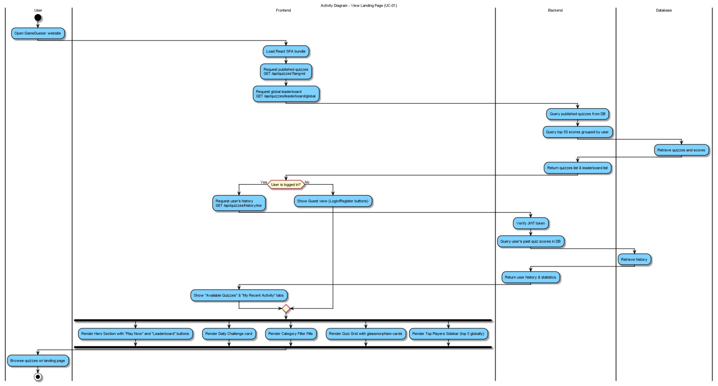

B.2.2 Register Account
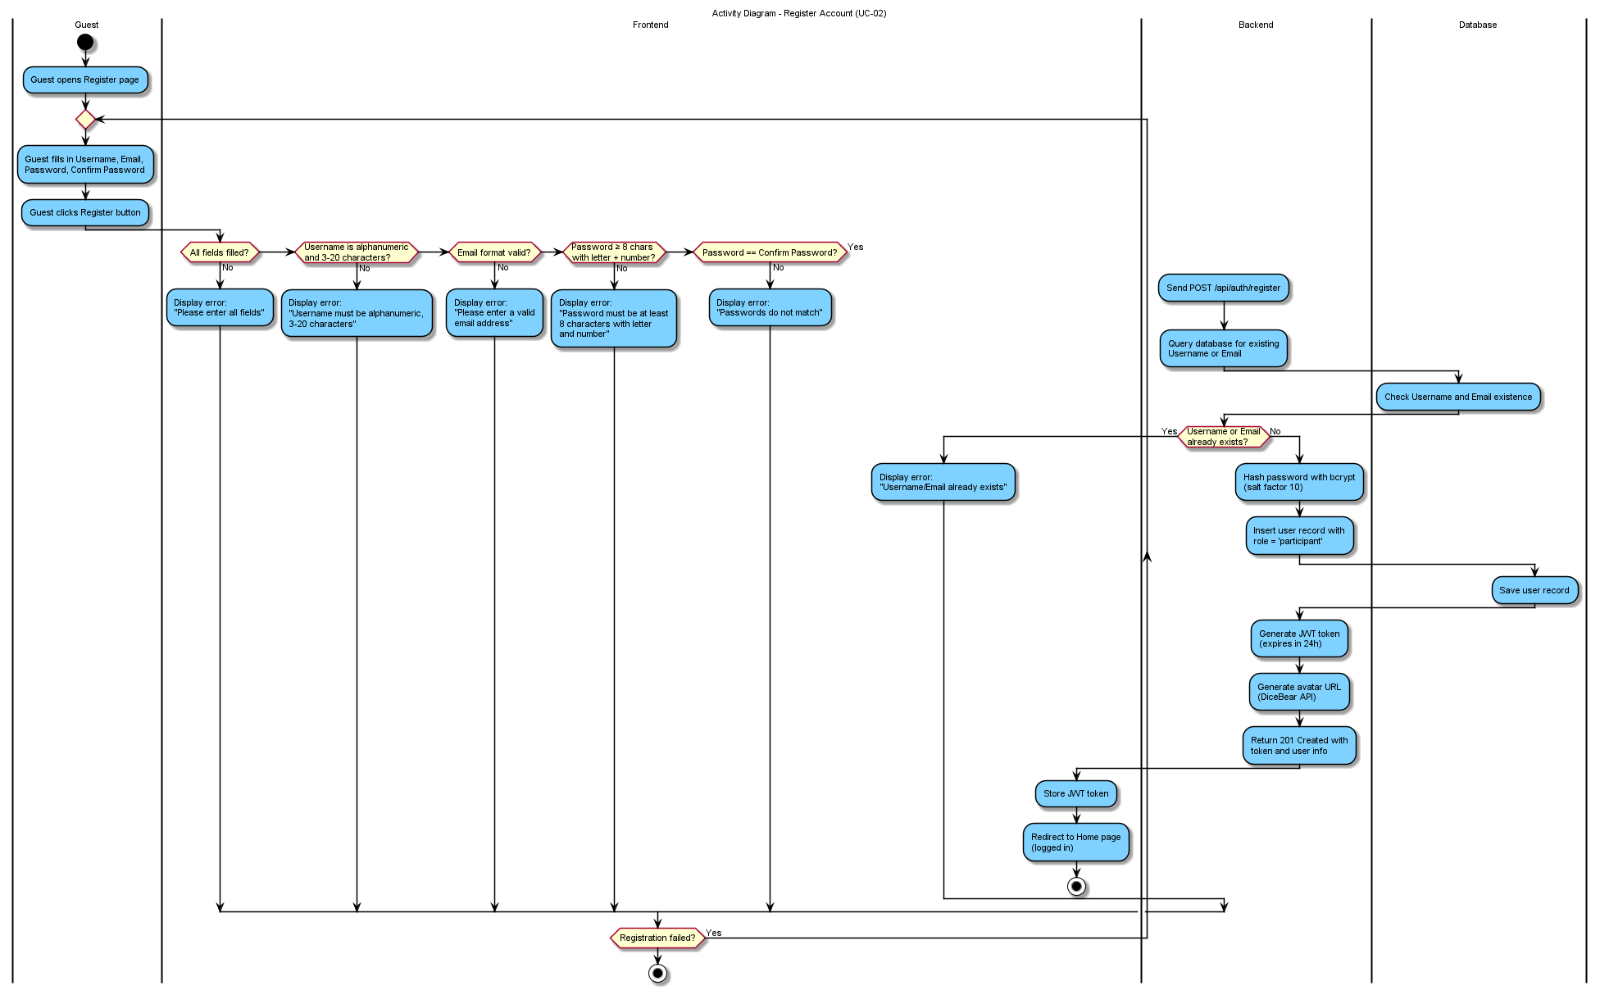
B.2.3 Login and Logout
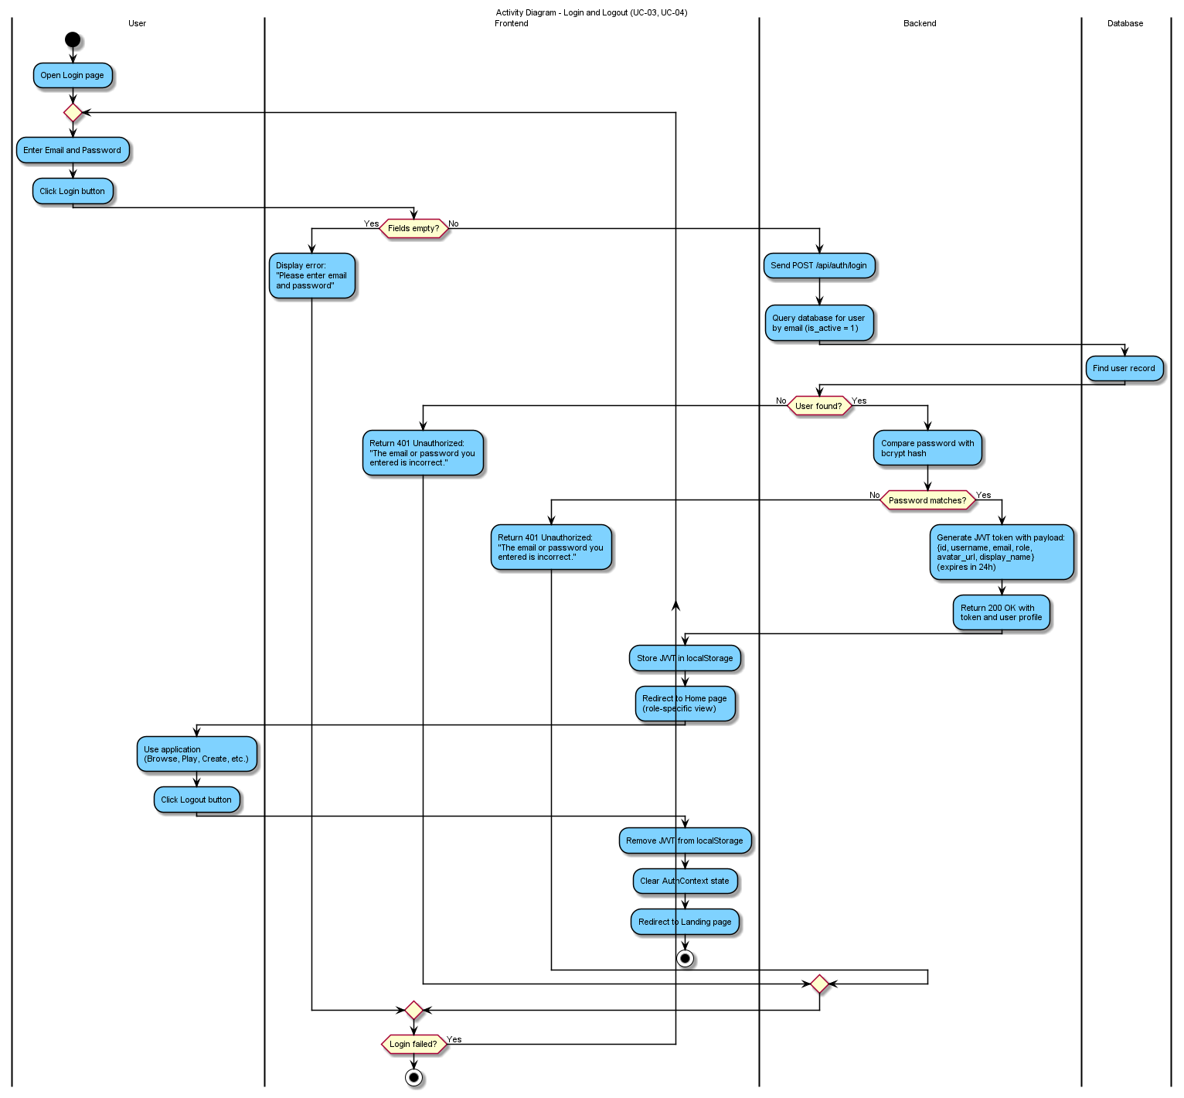

B.2.4 Update Profile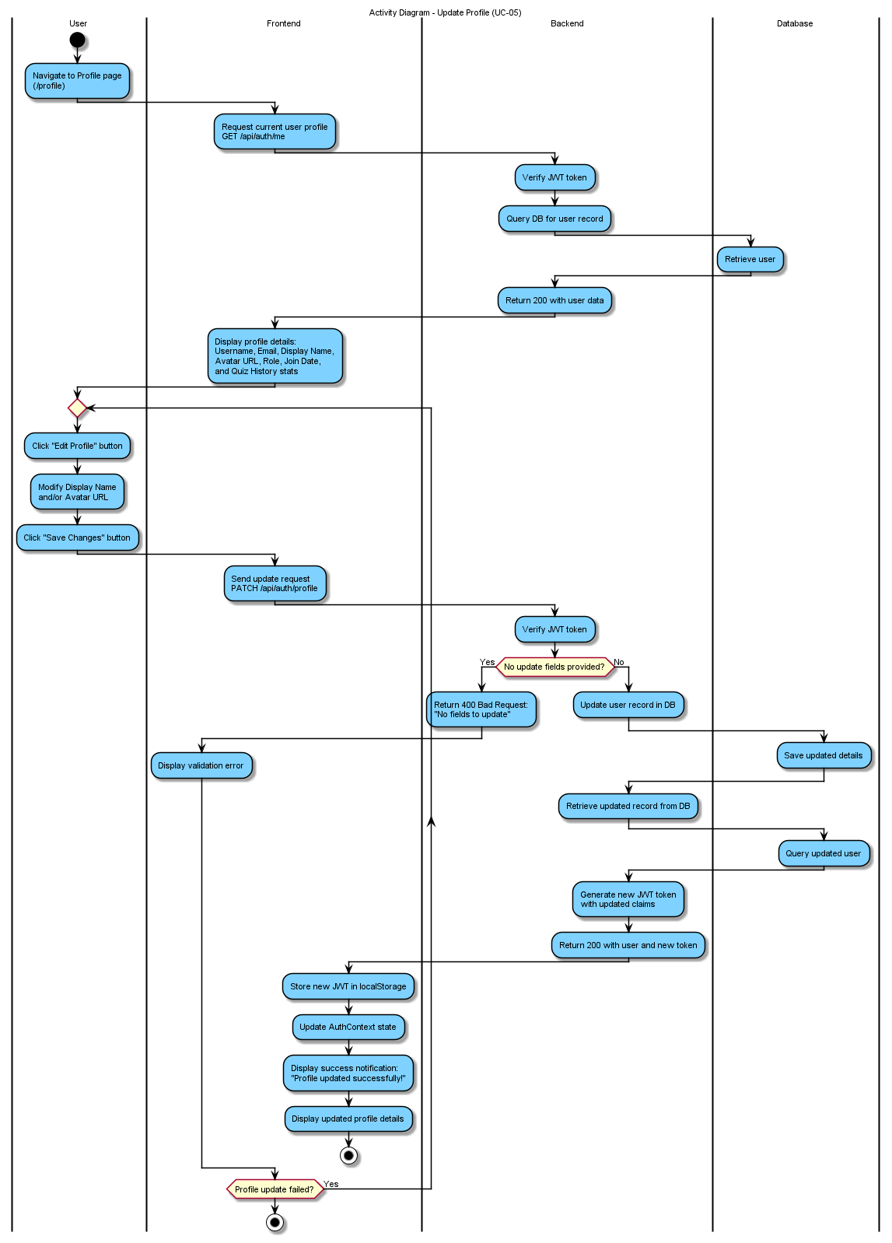

B.2.5 Browse Quizzes


B.2.6 Join Quiz Session + Answer Questions
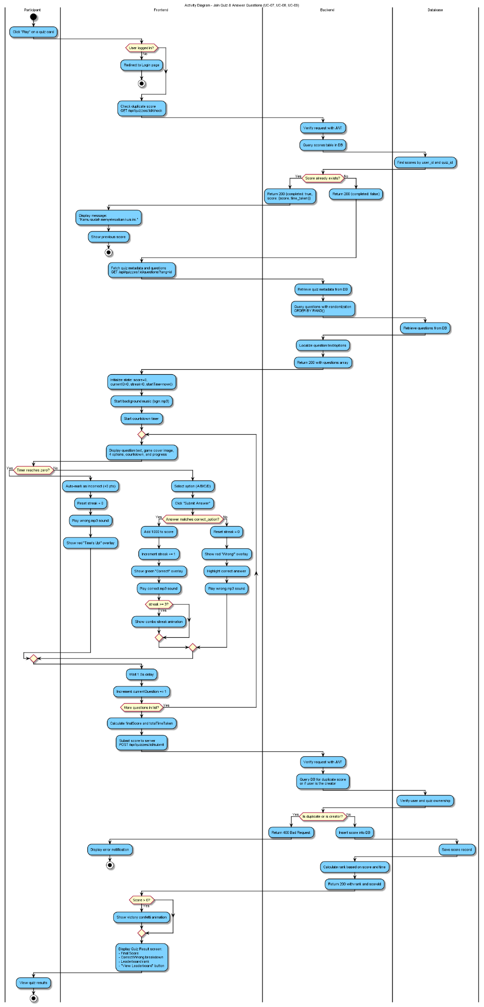

B.2.7 View Leaderboard
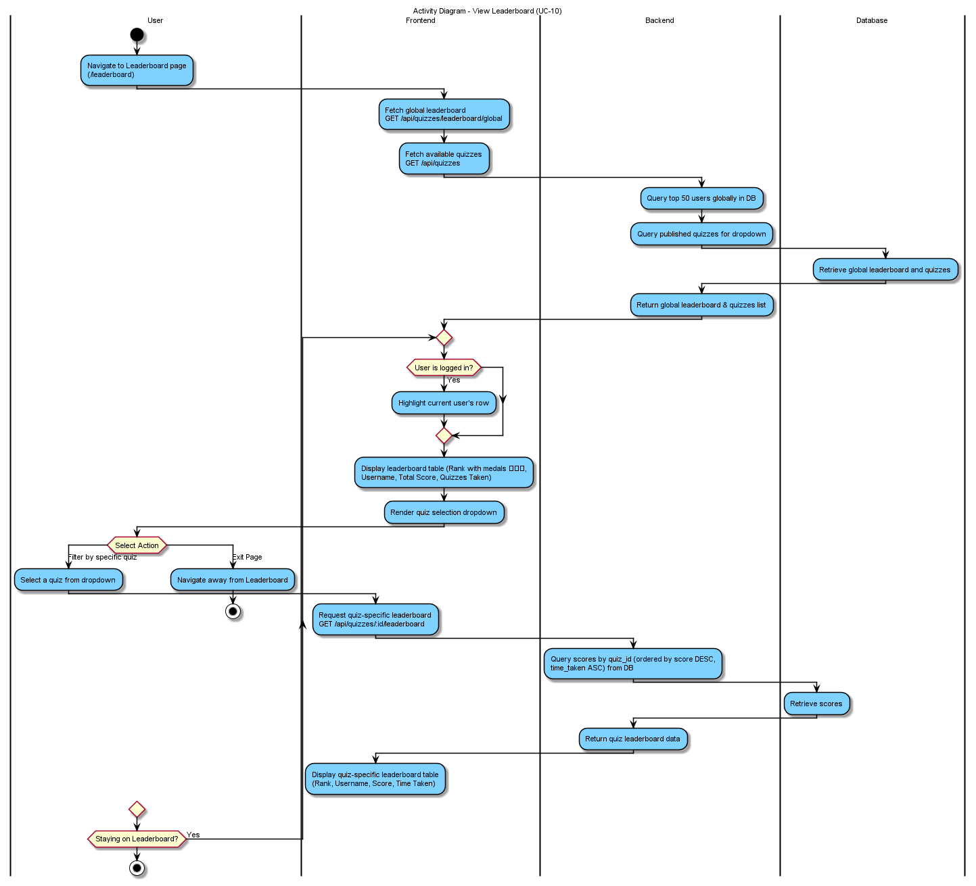

B.2.8 Upload Content
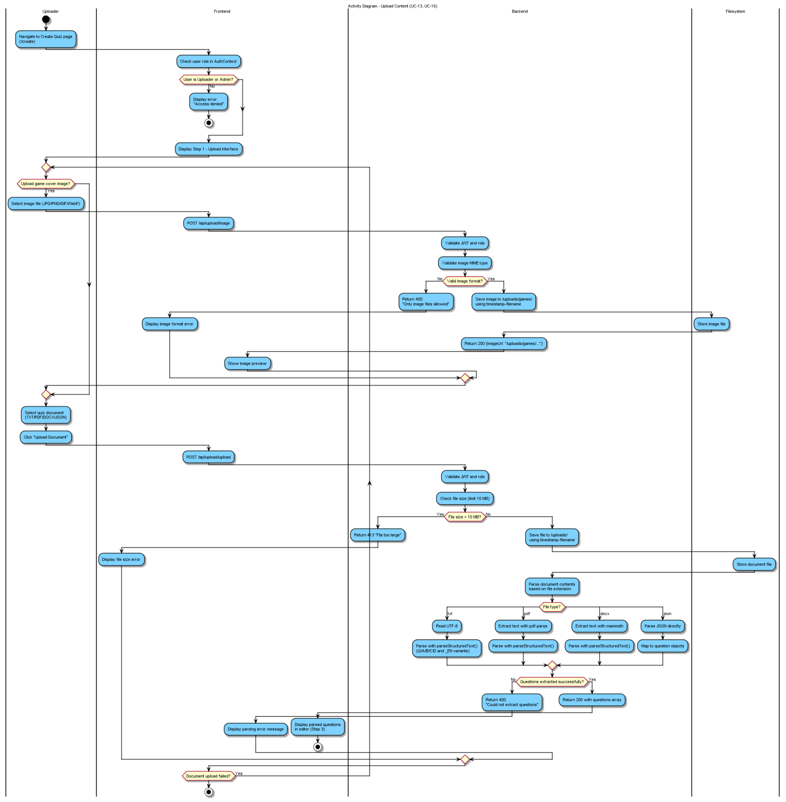

B.2.9 Create and Publish Quiz
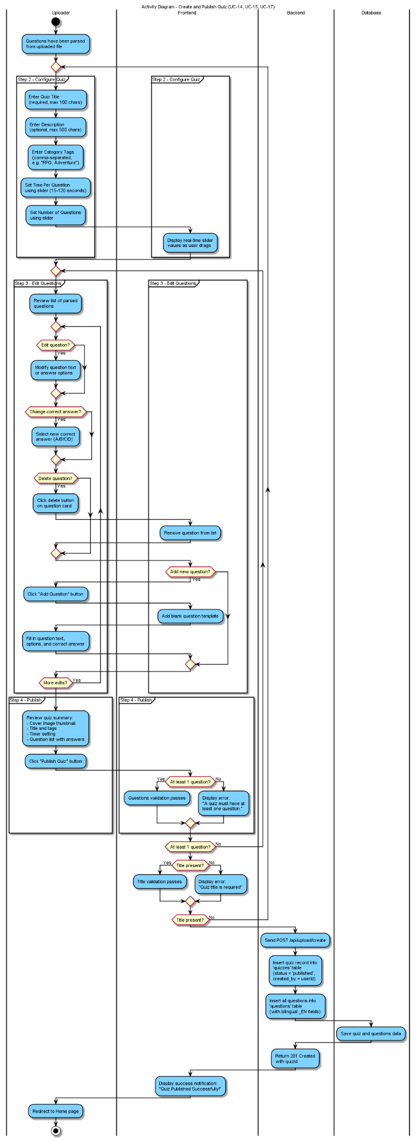

B.2.10 Manage User Accounts
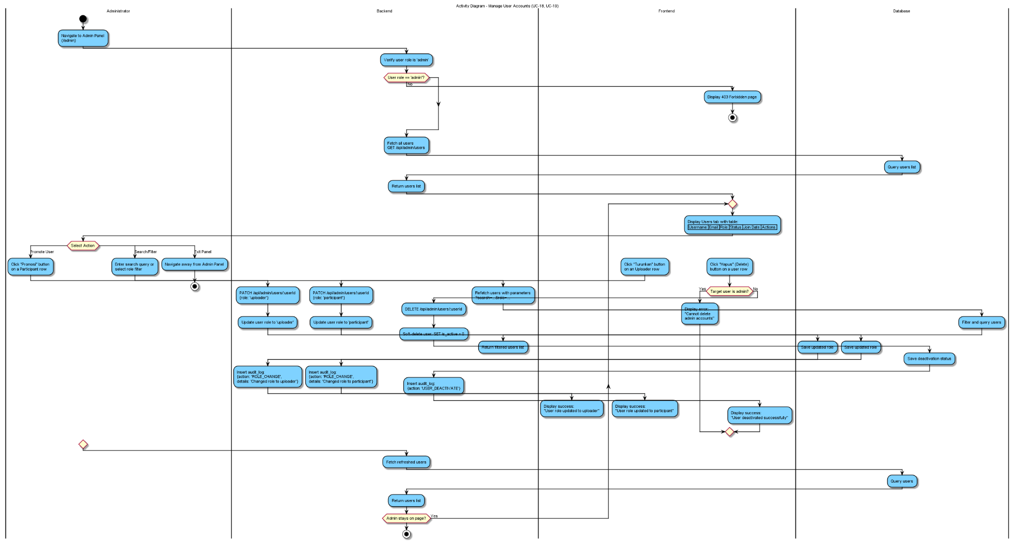

B.2.11 Moderate Content


B.2.12 View System Statistics
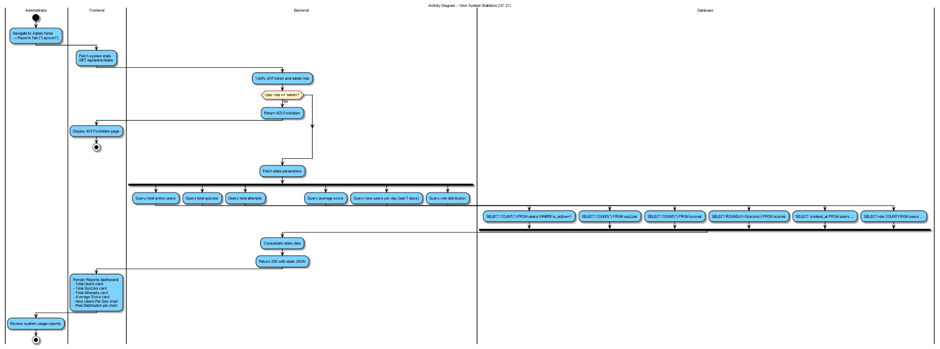

B.3 SEQUENCE DIAGRAM
B.3.1 View Landing Page
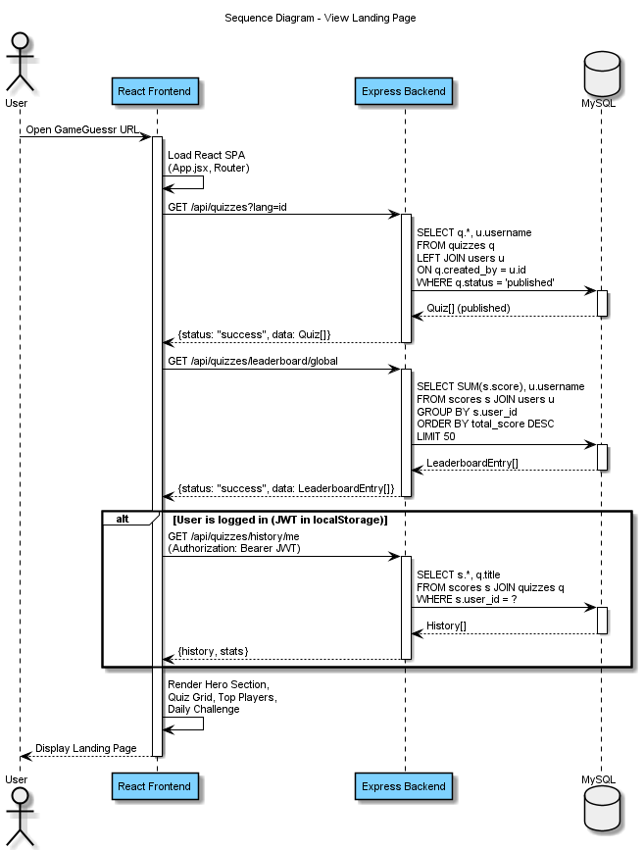
B.3.2 Register Account
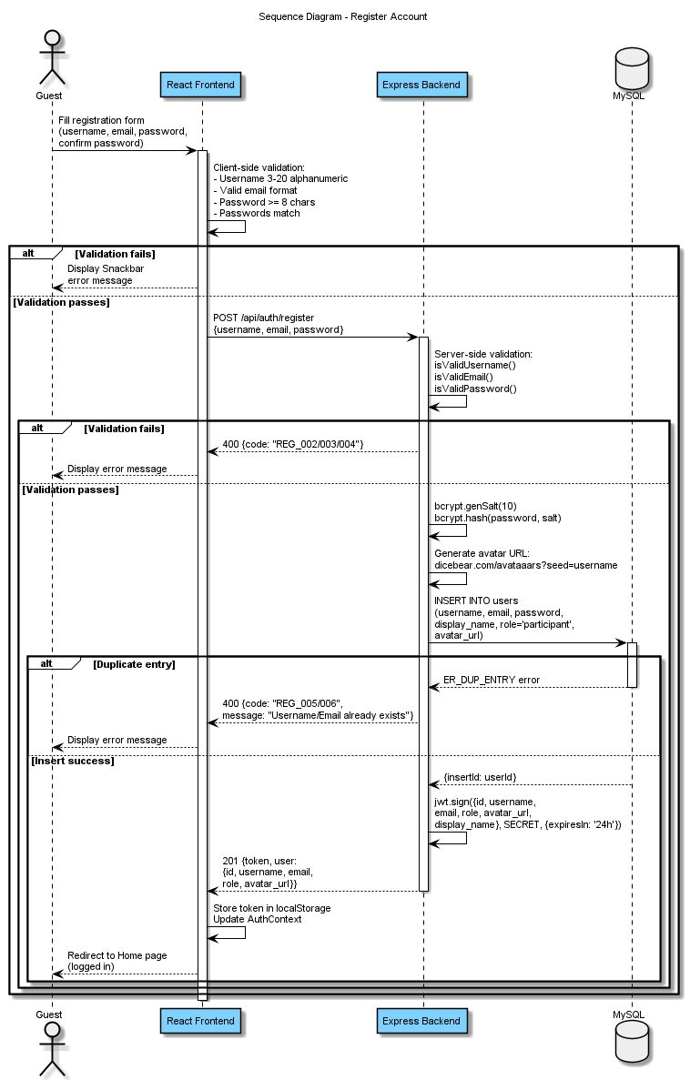
B.3.3 Login and Logout
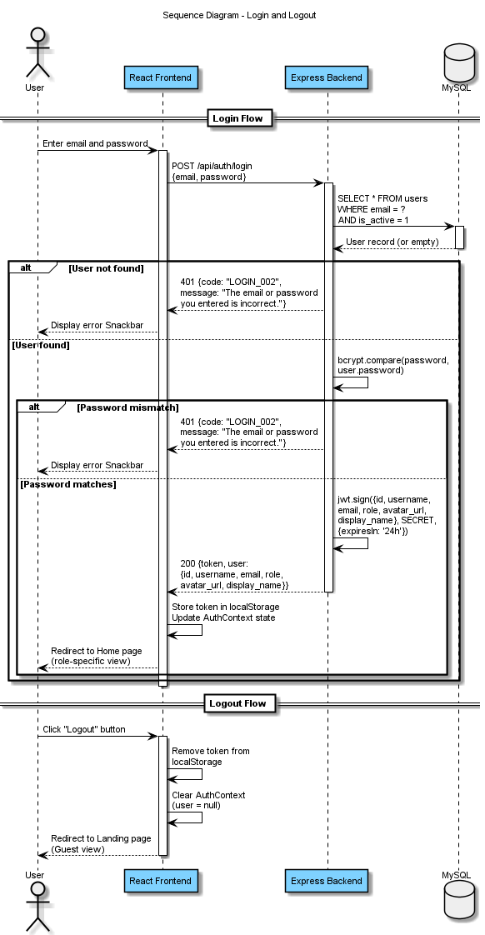

B.3.4 Update Profile
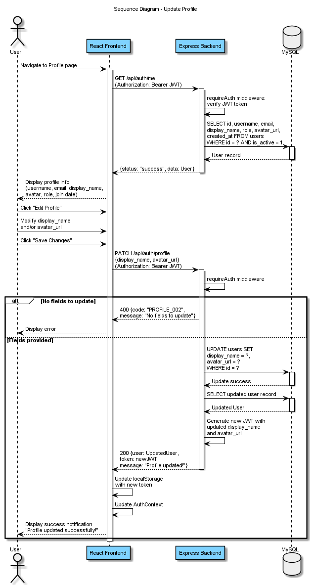
B.3.5 Browse Quizzes
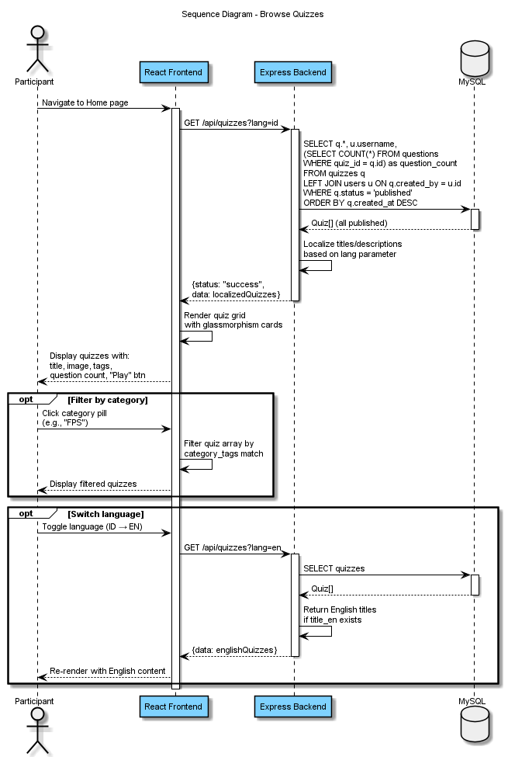
B.3.6 Join Quiz Session
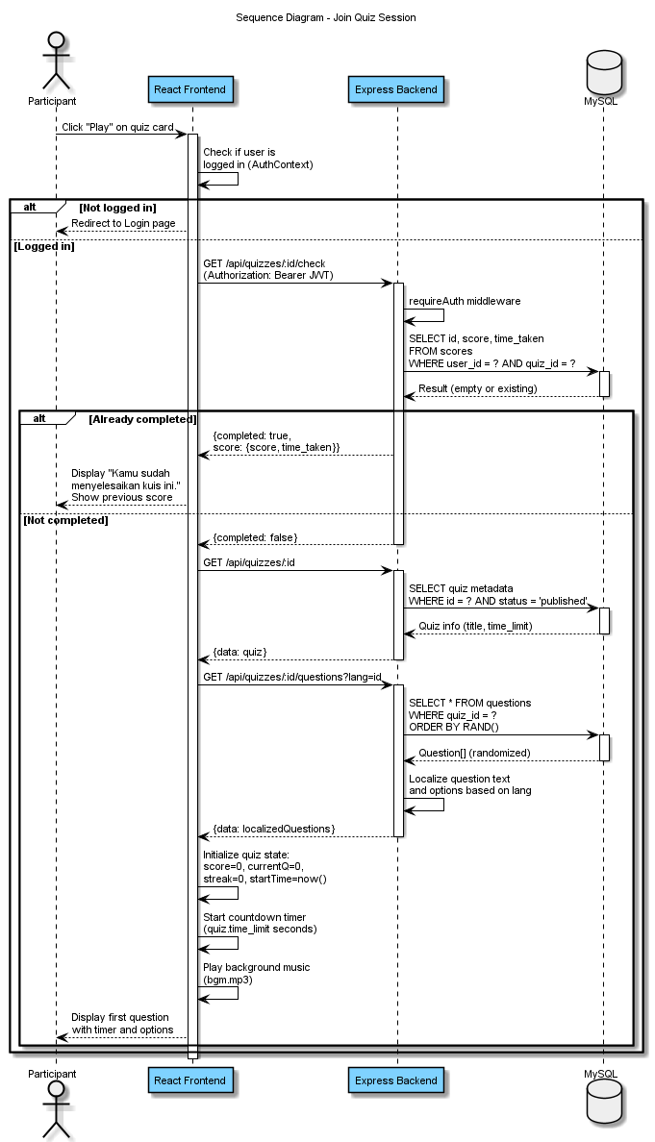
B.3.7 Answer Questions
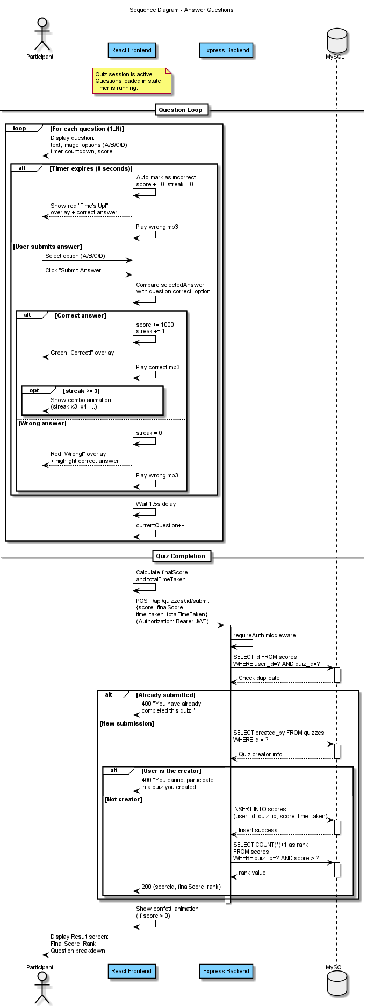
B.3.8 View Leaderboard
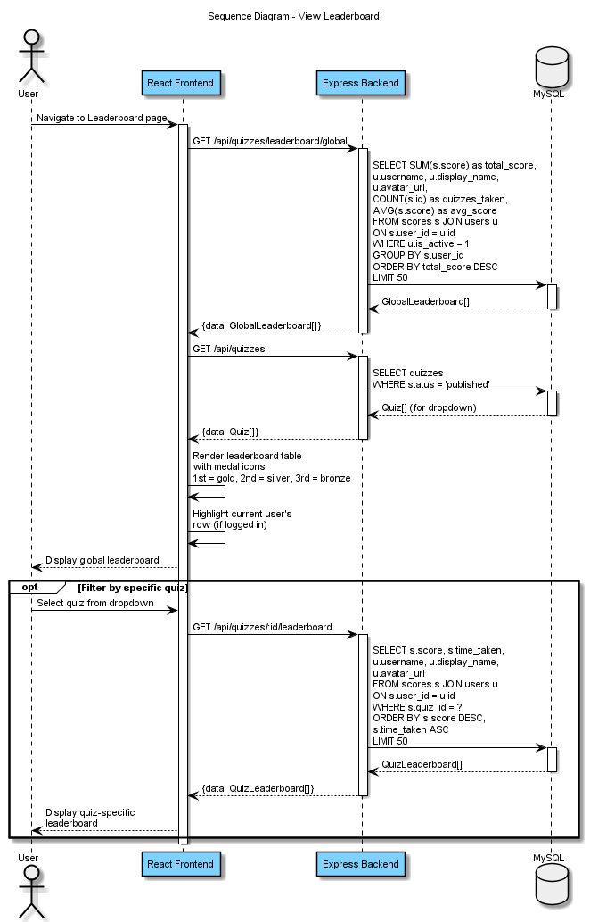
B.3.9 Upload Content
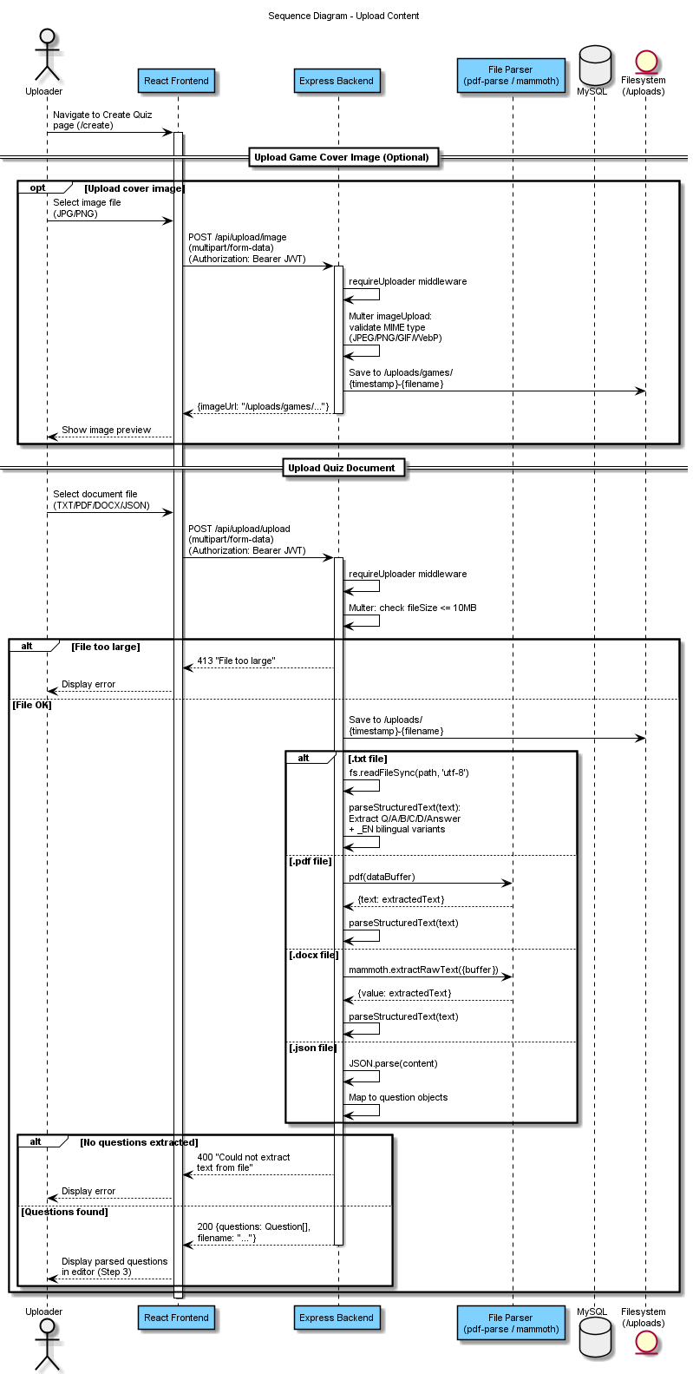
B.3.10 Create and Publish Quiz
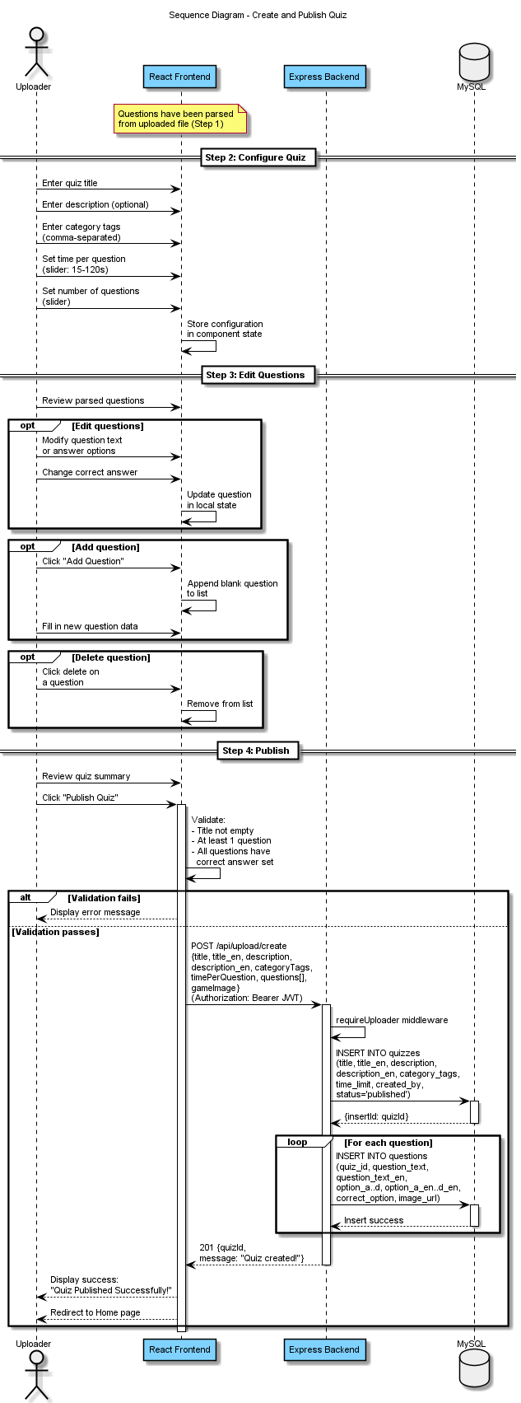
B.3.11 Manage User Accounts
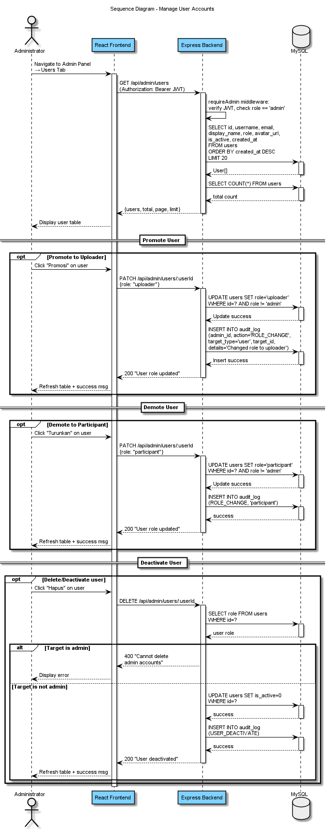
B.3.12 Moderate Content
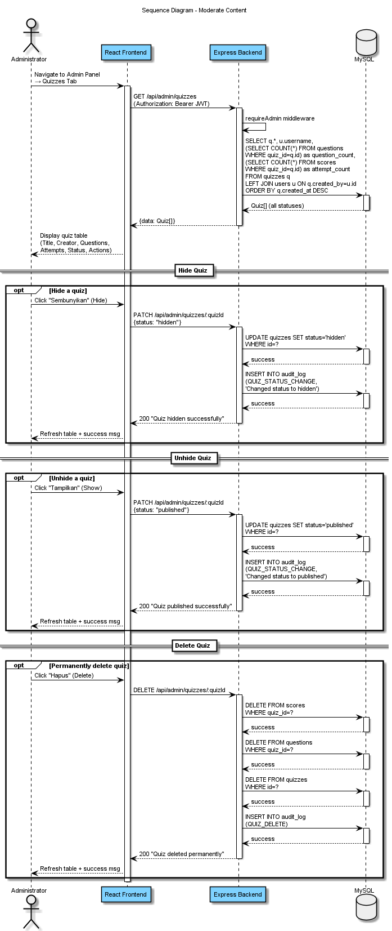
B.3.13 View System Statistics
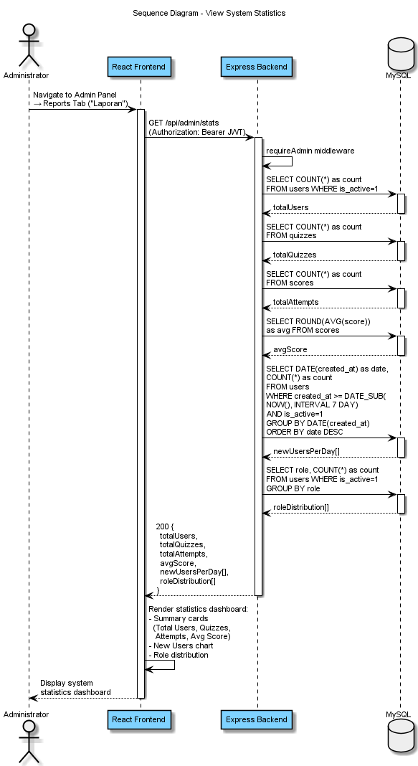
B.4 CLASS DIAGRAM

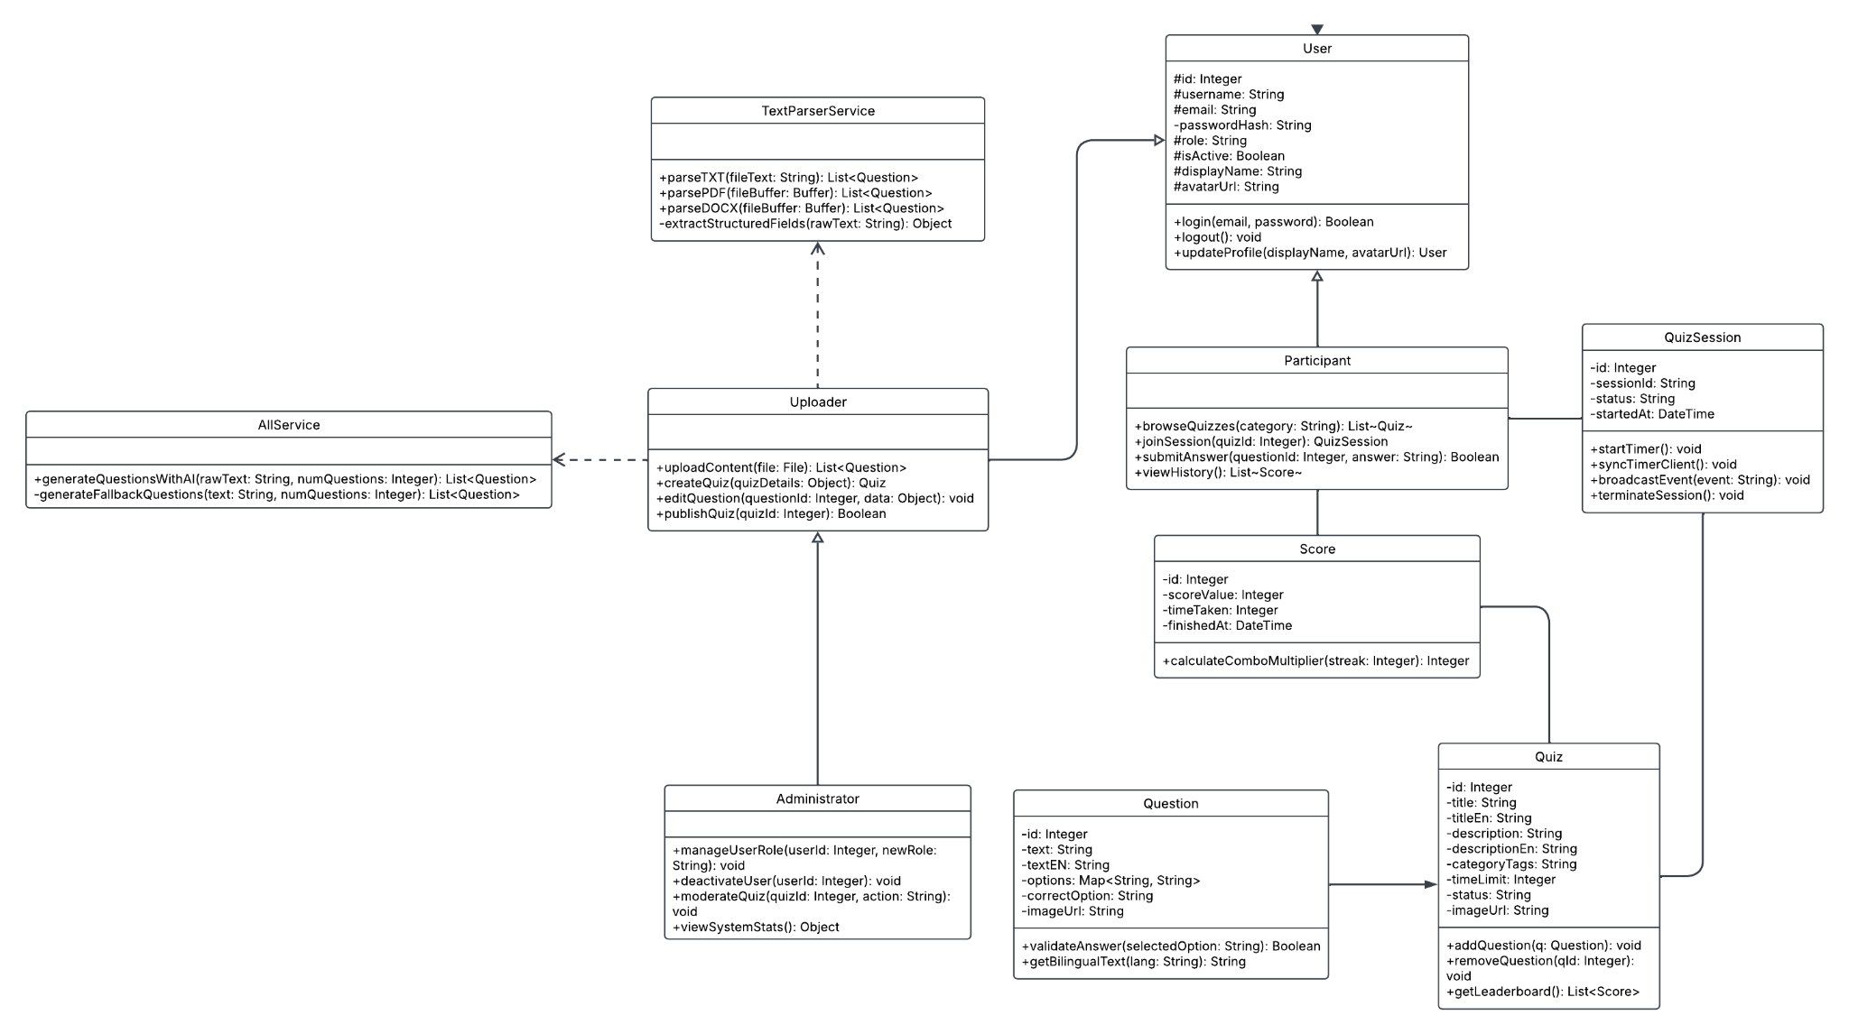

Appendix C: To Be Determined List
The following items remain to be determined and will be addressed in subsequent development phases:
TBD # | Description | Target Phase | Impact Area
TBD-01 | OAuth integration (Google, Facebook login) | Phase 3 | Authentication Module
TBD-02 | Password reset via email (Nodemailer + SMTP) | Phase 2 | Authentication Module
TBD-03 | Redis adapter for Socket.io horizontal scaling | Phase 3 | Quiz Module
TBD-04 | Cloud storage (AWS S3) for file uploads | Phase 3 | Uploader Module
TBD-05 | Comprehensive test suite (Jest, >80% coverage) | Phase 2 | All Modules
TBD-06 | Production deployment pipeline (CI/CD) | Phase 3 | DevOps
TBD-07 | Nginx reverse proxy and SSL termination | Phase 2 | Infrastructure
TBD-08 | Leaderboard caching (Redis, 60s TTL) | Phase 2 | Leaderboard Module
TBD-09 | User badges and achievement system | Phase 4 | Gamification
TBD-10 | Mobile-responsive optimization and PWA support | Phase 3 | Frontend

